1. List two security principles that were developed in your application showing the code that present these principles. Explain the benefits for each principle.​

**Principle: Least Privilege**

The principle of least privilege ensures that users and system components are granted only the permissions they need to perform their tasks, minimizing the risk of unauthorized actions or misuse.

**Code Example**:

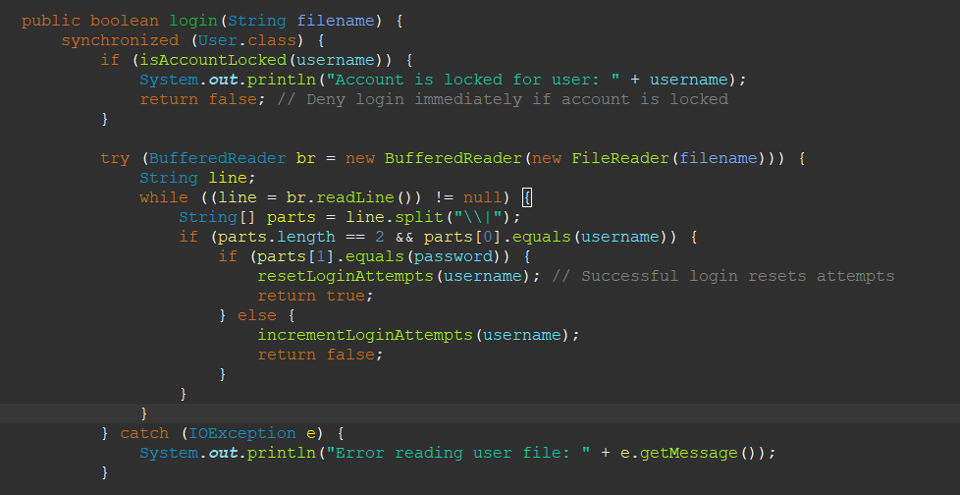This method ensures:

Only users with correct credentials can log in.

Users are limited to their roles:

**Passenger**: View and update personal information.

**FlightCrew**: View assigned flight details.

**CheckInAgent**: Register and update passenger and flight crew details.

* **Benefits**:

**Minimized Attack Surface**:

By restricting users to necessary actions, the application reduces opportunities for malicious activities like privilege escalation or data manipulation.

**Enhanced Role Security**:

Ensures that users only access resources pertinent to their roles. For example, passengers cannot access flight crew data.

**Error Isolation**:

Prevents a misconfigured or compromised user from impacting other parts of the system.

**Principle: Input Validation (Additional)**

Input validation ensures that all user-provided data is verified before processing, reducing the risk of injection attacks and system errors.

**Code Example**:

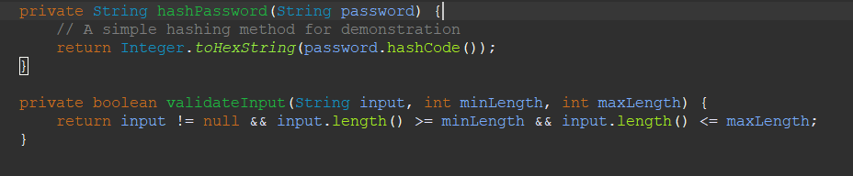The validateInput method ensures that inputs like usernames and passwords meet length requirements and are not null before proceeding.

* **Benefits**:

**Prevention of Injection Attacks**:

Ensures that malicious inputs, such as SQL injection payloads, are filtered out.

**Data Integrity**:

Validates that inputs conform to expected formats, reducing system errors.

**Improved User Experience**:

Provides immediate feedback when inputs are invalid, ensuring users correct mistakes ear

1. List two quality principles that were illustrated in your application showing the code that present these principles. Explain the benefits for each principle.

**Principle: Modularity**

Modularity divides a software system into separate components or modules, each responsible for a specific functionality. This improves readability, maintainability, and reusability of the code.

**Code Example**:

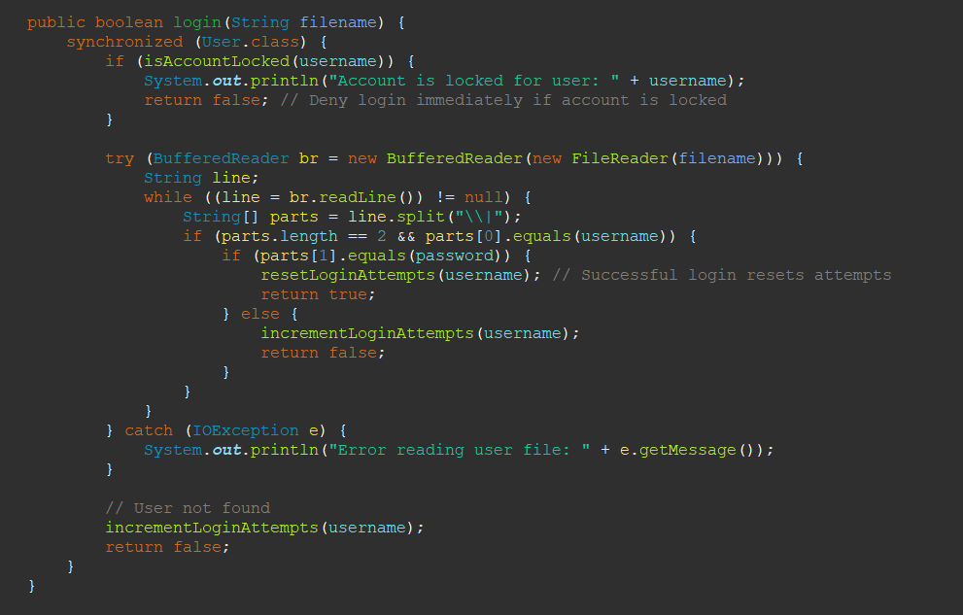

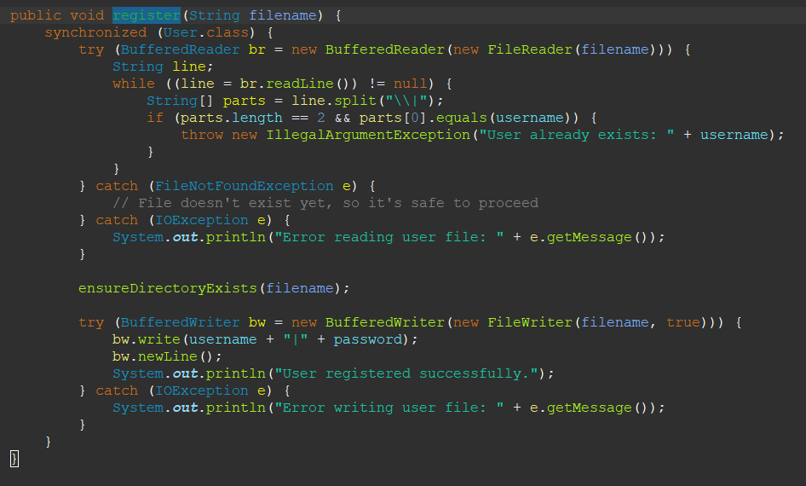**Explanation**:

Each method (login and register) is a separate module that handles a specific functionality.

These methods can be tested and debugged independently.

**Benefits**:

**Improved Maintainability**:

Changes in one module (e.g., login) do not affect others (e.g., registration), making it easier to modify and update the system.

**Reusability**:

Modular methods like login can be reused across multiple classes or features without duplication.

**Scalability**:

The modular structure simplifies adding new features, such as password reset, without overhauling the existing code.

**Principle: Readability and Code Clarity**

Readability ensures that the code is easy to understand, making it accessible to developers who may need to modify or debug it.

**Code Example**:

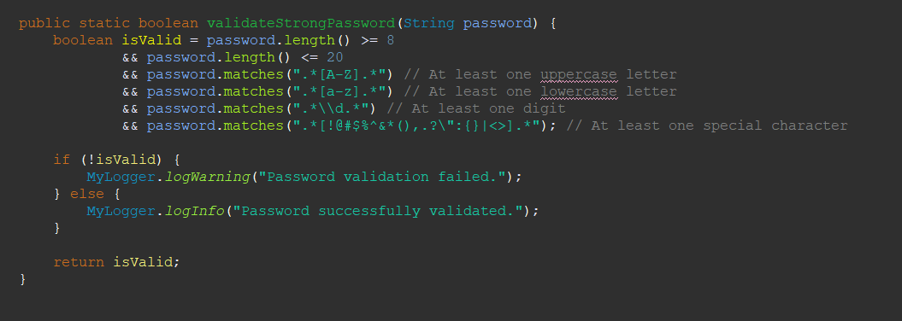 **Explanation**:

The validateStrongPassword method uses clear and descriptive comments for each validation check.

The code is straightforward, with proper formatting and meaningful variable names.

* **Benefits**:

**Ease of Understanding**:

Clear comments and structured code help developers quickly grasp the function's purpose.

**Efficient Debugging**:

Developers can easily identify errors or improve the code without extensive effort.

**Team Collaboration**:

Readable code fosters better communication and collaboration within a development team.

**Principle: Error Handling (Additional Quality Principle)**

Error handling ensures the application gracefully handles unexpected situations, improving reliability and user experience.

**Code Example**:

java

CopyEdit

try (BufferedReader reader = new BufferedReader(new FileReader(USER_FILE))) {

String line;

while ((line = reader.readLine()) != null) {

String[] parts = line.split("\\|");

if (parts.length == 2 && parts[0].equals(username)) {

String hashedPassword = hashPassword(password);

if (hashedPassword.equals(parts[1])) {

return true;

}

}

}

} catch (IOException e) {

System.out.println("Error reading user file: " + e.getMessage());

}

**Explanation**:

The login method catches IOException to ensure the application doesn’t crash if the user file is missing or unreadable.

Error messages are logged to notify developers of issues.

**Benefits**:

**Improved Reliability**:

The application continues functioning even in the face of file-related errors.

**Better Debugging**:

Logged error messages provide valuable insights into the root cause of issues.

1. Draw the use case diagram and the misuse case diagram for the application.

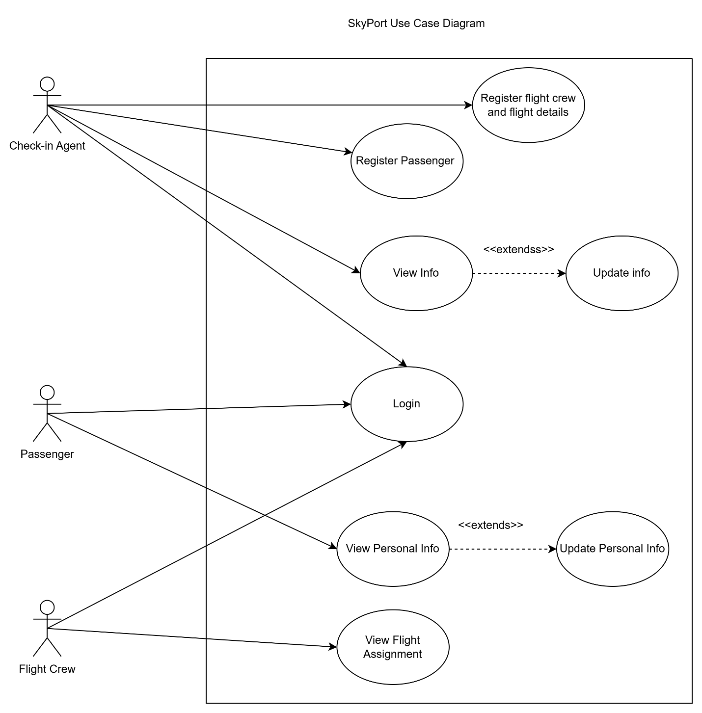

|  |  |  |  |
| --- | --- | --- | --- |
| Use case name | View Passenger Information | Use case number | 1 |
| Primary Actors | Passenger, Flight Crew | **Secondary Actors** | None |
| Description | Users can view relevant information, such as passenger or flight crew details. | | |
| Pre-condition | The user must be logged into the system with valid credentials | | |
| Post-condition | The system retrieves and displays information based on the user role. | | |
| Main flow | 1. The user selects "View Information" in their respective page. 2. The system retrieves the information from the appropriate file. 3. The system displays the data to the user. | | |
| Alternative flow | 1. If the user is not found in the file:    a. Display an error message ("Passenger not found.").    b. Log the event for debugging. | | |

|  |  |  |  |
| --- | --- | --- | --- |
| Use case name | Login | Use case number | 2 |
| Primary Actors | Passenger, Flight Crew, Admin | **Secondary Actors** | None |
| Description | Users log in to access their respective functionalities. | | |
| Pre-condition | The user is registered in the system and log in | | |
| Post-condition | The user is authenticated and redirected to the appropriate page. | | |
| Main flow | 1.The user enters a username and password. 2. The system validates the credentials. 3. If valid, the user is logged in and redirected.  4. the system displaly the functions | | |
| Alternative flow | 1. If the credentials are invalid:    a. Increment the failed login attempts.    b. Notify the user with remaining attempts.  c. if it enters valid credentials it get back to the main flow  2. If the account is locked:    a. Notify the user that the account is locked.    b. Log the lockout event. | | |

|  |  |  |  |
| --- | --- | --- | --- |
| Use case name | Update Passenger Information | Use case number | 3 |
| Primary Actors | Passenger, agent | **Secondary Actors** | None |
| Description | Passengers can update their personal information. | | |
| Pre-condition | The passenger must be in the system and logged in. | | |
| Post-condition | The updated information is saved in the respective file. | | |
| Main flow | 1. The passenger selects "Update Information." 2. The system prompts for updated details. 3. The passenger enters valid information. 4. The system validates and saves the changes. | | |
| Alternative flow | 1. If invalid data is entered:    a. Display an error message (e.g., "Invalid passport number.").    b. Prompt the passenger to correct the input. 2. If file writing fails:    a. Notify the user of the error.    b. Log the failure for debugging. | | |

|  |  |  |  |
| --- | --- | --- | --- |
| Use case name | Register User | Use case number | 4 |
| Primary Actors | Admin agent | **Secondary Actors** | None |
| Description | The admin agent registers new passengers or flight crew members in the system. | | |
| Pre-condition | The admin must be logged into the system | | |
| Post-condition | The new user is successfully added to the appropriate file. | | |
| Main flow | 1. The admin selects "Register New User." 2. The system prompts for user details. 3. The admin provides valid details. 4. The system validates and saves the new user information. | | |
| Alternative flow | 21. If the username already exists:    a. Display an error message ("User already exists."). b. Prompt to enter a unique username. 2. If invalid data is provided:    a. Notify the admin of the error.    b. Log the issue for debugging. | | |

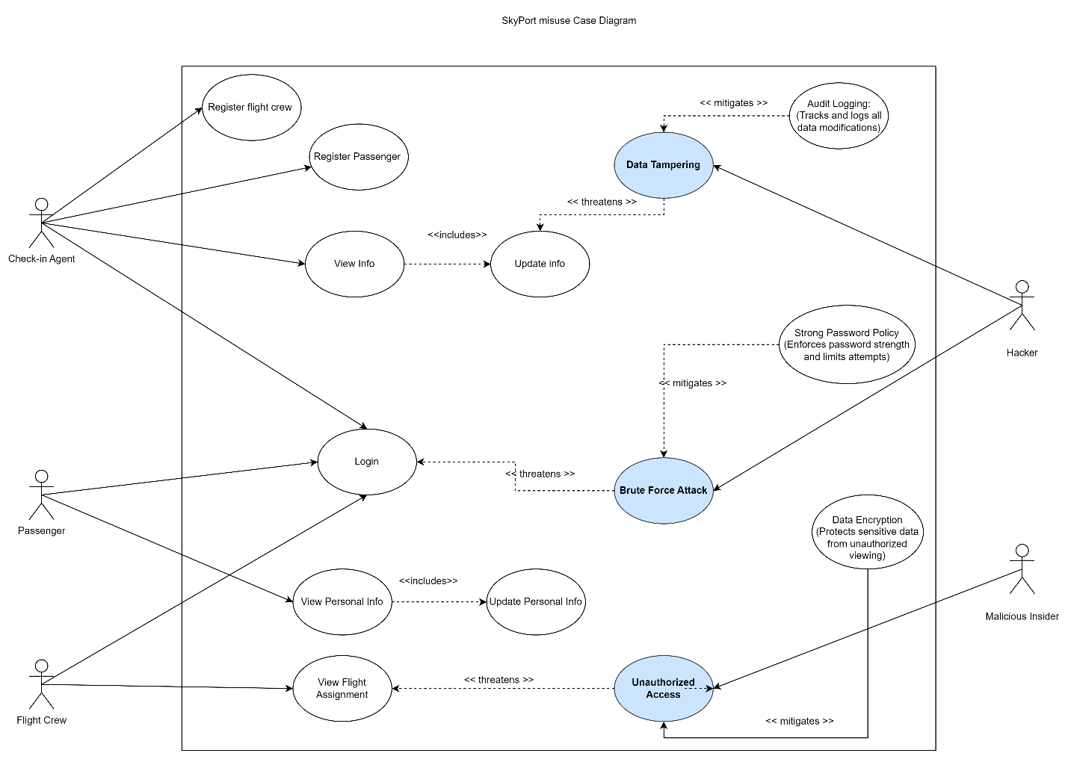

1. Create a data flow diagram.

Context diagram

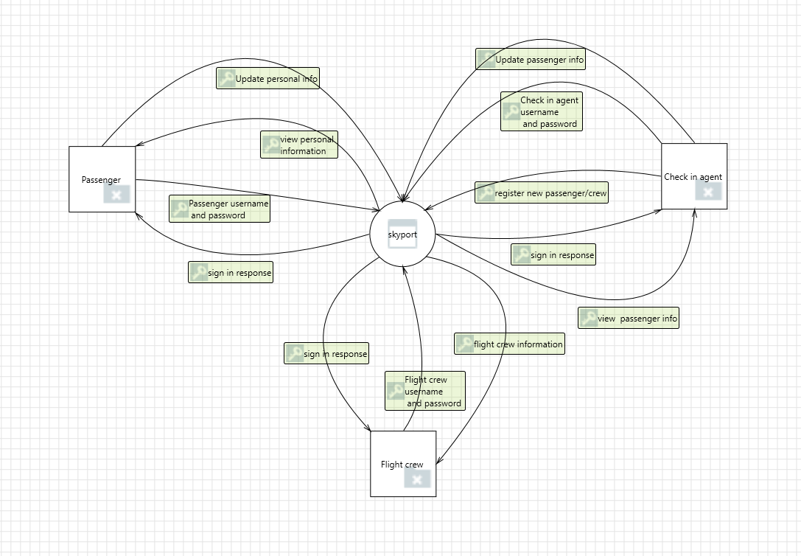

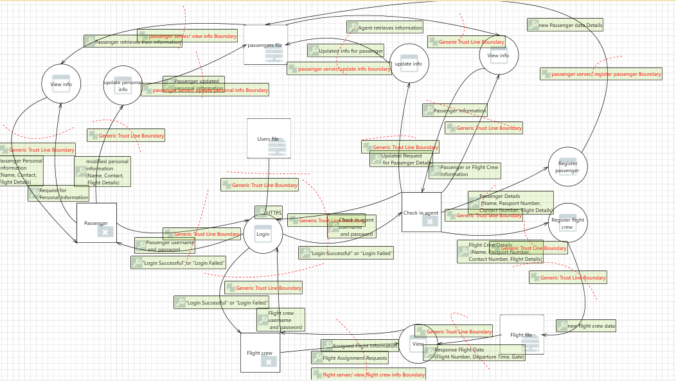

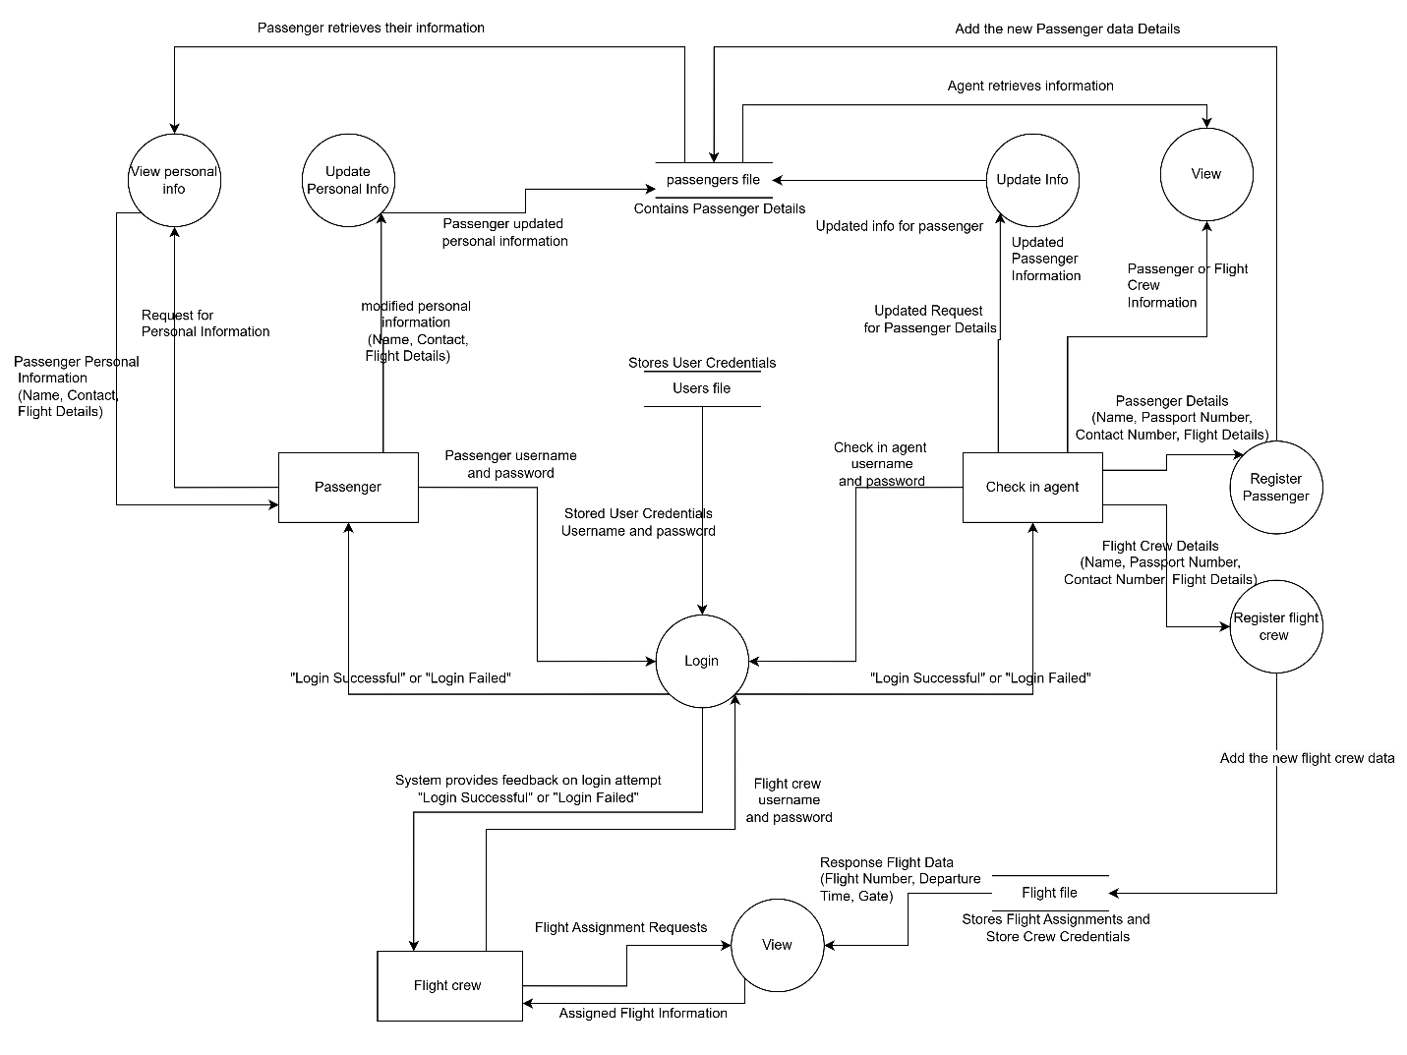

|  |  |  |  |
| --- | --- | --- | --- |
| Use case name | Login | Use case number | 1 |
| Primary Actors | Agent, flight crew, passenger | **Secondary Actors** | None |
| Description | Users log into the system to access their respective functions. The system enforces security mechanisms to prevent brute force attacks, unauthorized access, and data tampering. | | |
| Pre-condition | |  | | --- | | The user must be registered in the system. | | | |
| Post-condition | |  |  | | --- | --- | | The user is authenticated and granted access based on their role. If authentication fails multiple times, the account is locked temporarily. | | |  | | | |
| Main flow | 1. The user enters their **username** and **password**. 2. The system validates the credentials:   a. If valid → User is authenticated and redirected to the corresponding dashboard.   b. If invalid → Proceed to alternative flow. 3. The user's role (Agent, Flight Crew, Passenger) is determined. 4. The user gains access to the permitted functions based on their role. | | |
| Alternative flow | **2.a Invalid Credentials:**   1. The system displays an **error message** ("Invalid credentials. Attempts remaining: X").   2. The system logs the failed login attempt and updates the counter.   3. The user is prompted to retry login. **2.b Maximum Attempts Exceeded:**   1. If three failed attempts occur, the system **locks the account temporarily**.  2. The system **logs the brute force attempt** in logfinal.log  3. The system **waits 3 minutes** before allowing new login attempts.    4. The use case resumes at **Main Flow Step 1** after the cooldown period. | | |

1. Analyze the created data flow diagram for potential threats.

Done report 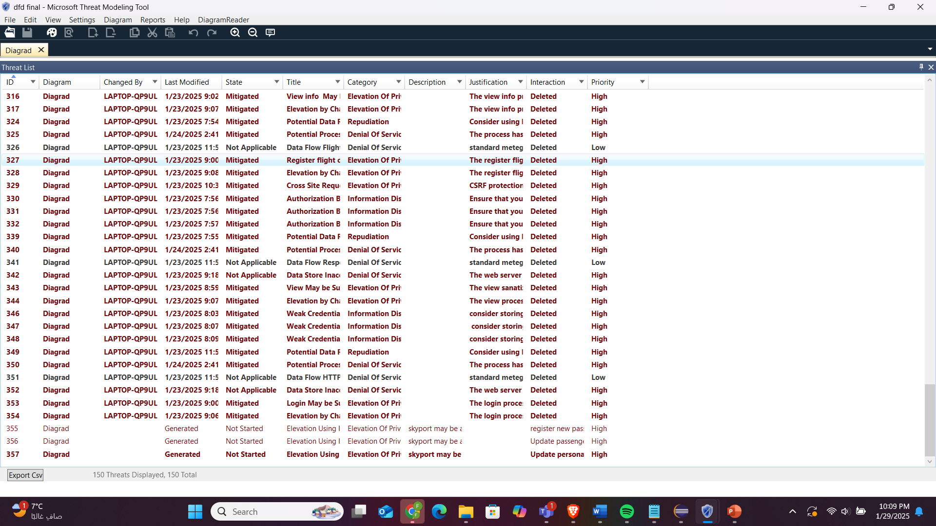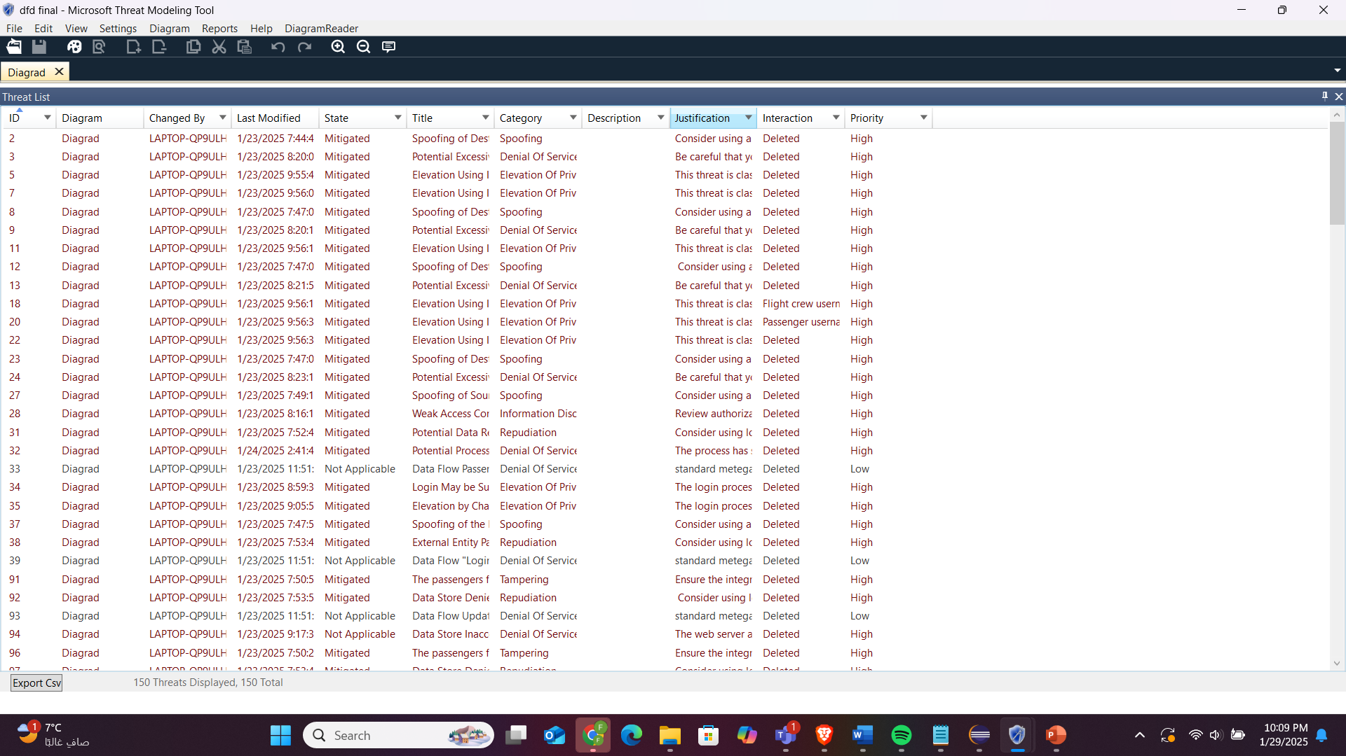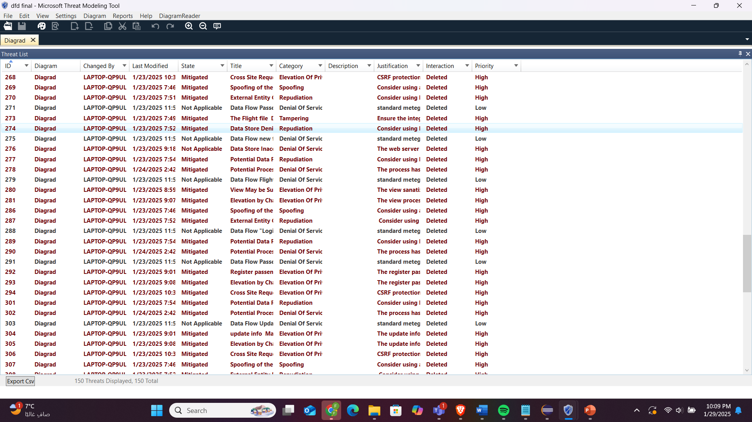

1. Generate a full threat modeling report.

Done report

1. What type of testing methods will you use to test the satisfaction of the application to the requirements and what are the benefits?
2. **Unit Testing**  
   It’s a way to check small parts of the app (like functions or methods) to make sure they work right. You test one piece at a time, without looking at the whole app.

**How It’s Done**:

* You write tests for a specific function (e.g., *authenticateUser* in a login feature).
* Fake things like databases (mocking) so you're only testing that one piece of code.
* Check if the function gives the right results, handles edge cases, or throws errors when it should.

**Tools will be Used,** For Java: JUnit.

**Example From My App**:

* Test *authenticateUser*:
  + If username & password are correct, it should return *true*.
  + If wrong, it should return *false*.
* Test *incrementLoginAttempts*:
  + Make sure failed login attempts increase for a specific username.

**Why It’s Good**:

* Catches bugs early, so you fix them before things get messy.
* Helps you write cleaner code since everything is more organized.
* Makes refactoring safer—you won’t accidentally break stuff.
* It’s quick and gives you fast feedback while coding.

1. **Integration Testing**  
   This type of testing checks if different parts of your app (modules) work well together and share data correctly.

**How It’s Done**:

* Test a few parts of your app together (like the login feature and the database).
* Use real or fake data to see if everything behaves right.
* Look for problems like wrong data being shared, broken APIs, or workflows that don’t work.

**Tools You Can Use**:

* For Java: Spring Test.
* For mocking and injecting stuff: Mockito.
* Or use a real database for a more realistic test.

**Example From My App**:

* Test how the login system talks to the database:
  + If the username & password are correct, it should pull the right user info and update loginAttempts.
* Check if the password hashing works properly with *authenticateUser* and the user database.

**Why It’s Good**:

* Makes sure different parts of your app can work together smoothly.
* Finds issues in workflows that involve multiple steps (like the login process).
* Helps test real-life scenarios so your app is more reliable.
* Lowers the chance of things going wrong when you deploy it.

1. **User Acceptance Testing (UAT)**  
   This is where real users or stakeholders test the app to see if it meets their needs and works how they expect.

**How It’s Done**:

* Set up test scenarios that match real-life situations.
* Run the tests in a staging environment (like a fake version of your app, but close to the real thing).
* Get actual users (e.g., airport staff or passengers) to use the app and share feedback.
* Focus on how easy it is to use, if everything works, and the overall experience.

**Example From My App**:

* Test the login flow with different users:
  + **Passenger Test**: Check if passengers can log in, see flight details, and update their info.
  + **Agent Test**: Make sure agents can register passengers and edit passenger data.
  + **Flight Crew Test**: Confirm flight crew can log in and view their assigned flights.
* Ask users if they find the app easy to use and if it makes sense.

**Why It’s Good**:

* Makes sure the app fits what users need and expect.
* Helps catch usability issues before launch.
* Shows the app delivers value to users.
* Builds trust with stakeholders by involving them in the testing.

1. **Smoke Testing**  
   This is a quick check to make sure the most important parts of the app work before doing more detailed testing. It’s also called build verification testing.

**How It’s Done**:

* Pick the key features of your app (e.g., login, registration, data fetching).
* Do a quick round of tests to see if they’re working fine.

**Examples of Smoke Tests**:

* Does the app open and show the main menu properly?
* Can users log in with the right username and password?
* Are invalid logins rejected correctly?

**Example From My App**:

* After every new build or update:
  + Check if the login page loads and users can log in.
  + Test if a new user can register and log in right after.
  + Verify accounts lock properly after too many failed logins.

**Why It’s Good**:

* Quickly catches big issues (like login being broken) so you don’t waste time testing deeper.
* Saves effort by making sure the app is stable before running detailed tests like integration or UAT.
* Gives fast feedback for developers during updates and deployments.
* Helps focus on fixing critical problems early.

1. What type of security testing methods will you use and what are the benefits?

**Security Regression Testing**  
This checks if new updates, patches, or bug fixes have caused old security issues to come back or created new ones.

**How It’s Done**:

* Run old security tests again after every update or deployment.
* Automate checks for vulnerabilities like SQL injection, XSS, or CSRF.
* Use tools or scripts in your CI/CD pipeline to make this process faster.

**Types of Security Regression Testing**:

1. **Manual Testing**:
   * Testers go through security-critical areas like login, session handling, and data encryption by hand.
2. **Automated Testing**:
   * Use tools like SonarQube, OWASP ZAP, or Burp Suite to run automated checks.
3. **Patch Verification**:
   * Check if fixes for past vulnerabilities work without breaking anything else.

**Why It’s Good**:

* Makes sure old security holes don’t come back.
* Ensures new features or fixes don’t create new security problems.
* Keeps your app secure even in fast-moving development environments.

**Static Application Security Testing (SAST)**  
SAST is a type of testing that looks at your app’s code (without running it) to find security flaws. It’s a *white-box testing* method, meaning it works directly with the code.

**How It’s Done**:

* Use SAST tools to scan your code and find problems like:
  + SQL injection.
  + Hardcoded secrets (e.g., passwords, API keys).
  + Bad input validation.
  + Weak cryptography.
* Review the code manually (peer reviews) to catch insecure coding practices.
* Add SAST tools to your CI/CD pipelines so the code gets scanned every time there’s a new update.

**Types of SAST Tools**:

1. **Source Code Analysis Tools**:
   * Scan your source code for issues.
   * Examples: SonarQube, Checkmarx, Fortify Static Code Analyzer.
2. **Binary Code Analysis Tools**:
   * Analyze compiled binaries if you don’t have access to the source code.
   * Examples: Coverity, Veracode.
3. **Code Linters with Security Features**:
   * Lightweight tools to catch smaller security issues and code violations.
   * Examples: PMD (for Java), ESLint (for JavaScript).

**Why It’s Good**:

* Finds problems early, so fixing them is cheaper and faster.
* Gives developers detailed advice on how to fix security issues.
* Helps write better, more secure code.
* Makes sure the code follows security standards (like OWASP Top 10 or CWE/SANS Top 25).

**Dynamic Application Security Testing (DAST)**  
DAST is a *black-box testing* method that tests your app while it’s running to find security issues. It doesn’t need access to the source code and focuses on how the app behaves when attacked.

**How It’s Done**:

* Run automated tools on the live app to simulate attacks like:
  + SQL Injection.
  + Cross-Site Scripting (XSS).
  + Weak session handling (e.g., insecure cookies).
* Perform penetration testing to mimic real-world attacks.
* Check HTTP responses, headers, and data flow for vulnerabilities.

**Types of DAST Tools**:

1. **Web Application Scanners**:
   * Scan web apps for security issues.
   * Examples: OWASP ZAP, Burp Suite, Acunetix.
2. **API Security Scanners**:
   * Test APIs for weak endpoints and authentication problems.
   * Examples: Postman, SoapUI.
3. **Vulnerability Scanners**:
   * Look at the app’s environment for known vulnerabilities.
   * Examples: Nessus, Qualys.

**Why It’s Good**:

* Finds problems that only show up while the app is running, like bad session handling or insecure headers.
* Simulates real attacks to show how hackers might exploit your app.
* Helps spot issues in third-party libraries, APIs, and components.
* Reduces the chance of runtime exploits in production.

1. Apply quality-based testing techniques such as unit testing by showing the test plan and providing screenshots for the testing.

# Login Test Results

|  |  |  |  |  |  |
| --- | --- | --- | --- | --- | --- |
| Test ID | Test case description | Inputs | Expected | Actual | Status |
| UT001 | Verify login with correct username and password | username: testUser1, password: Test@123 | Login successful | Login successful | Pass |
| UT002 | Verify login with incorrect username | username: wrongUser, password: Test@123 | Login failed | Login failed | Pass |
| UT003 | Verify login with correct username and incorrect password | username: testUser1, password: WrongPass123 | Login failed | Login failed | Pass |
| UT004 | Verify login with incorrect username and password | username: wrongUser, password: WrongPass123 | Login failed | Login failed | Pass |
| UT005 | Verify handling of username too short | username: us, password: ValidPass123 | Exception: Invalid username or password length | Exception: Invalid username or password length | Pass |
| UT006 | Verify handling of username too long | username: thisUsernameIsWayTooLongToBeAccepted, password: ValidPass123 | Exception: Invalid username or password length | Exception: Invalid username or password length | Pass |
| UT007 | Verify handling of password too short | username: validUser, password: short | Exception: Invalid username or password length | Exception: Invalid username or password length | Pass |
| UT008 | Verify handling of password too long | username: validUser, password: thisPasswordIsWayTooLongToBeAcceptedAndShouldFail | Exception: Invalid username or password length | Exception: Invalid username or password length | Pass |
| UT009 | Verify account lock after 3 failed attempts | username: testUser1, password: WrongPass123 (3 attempts) | Account locked after 3 attempts | Account locked after 3 attempts | Pass |

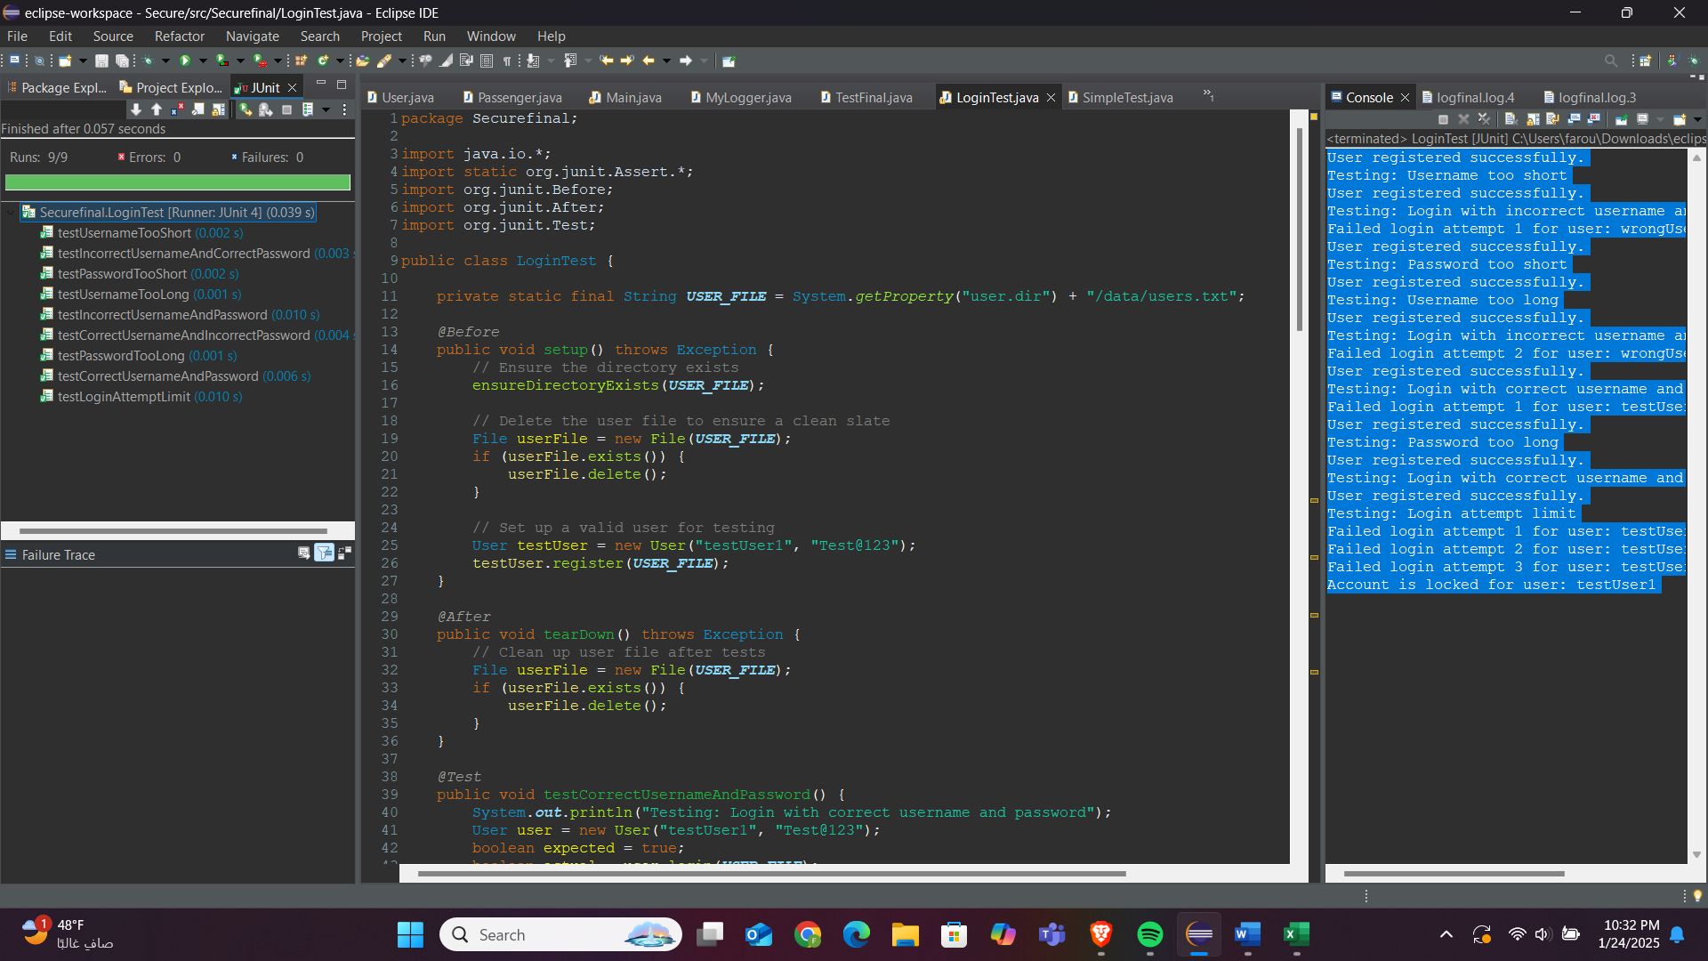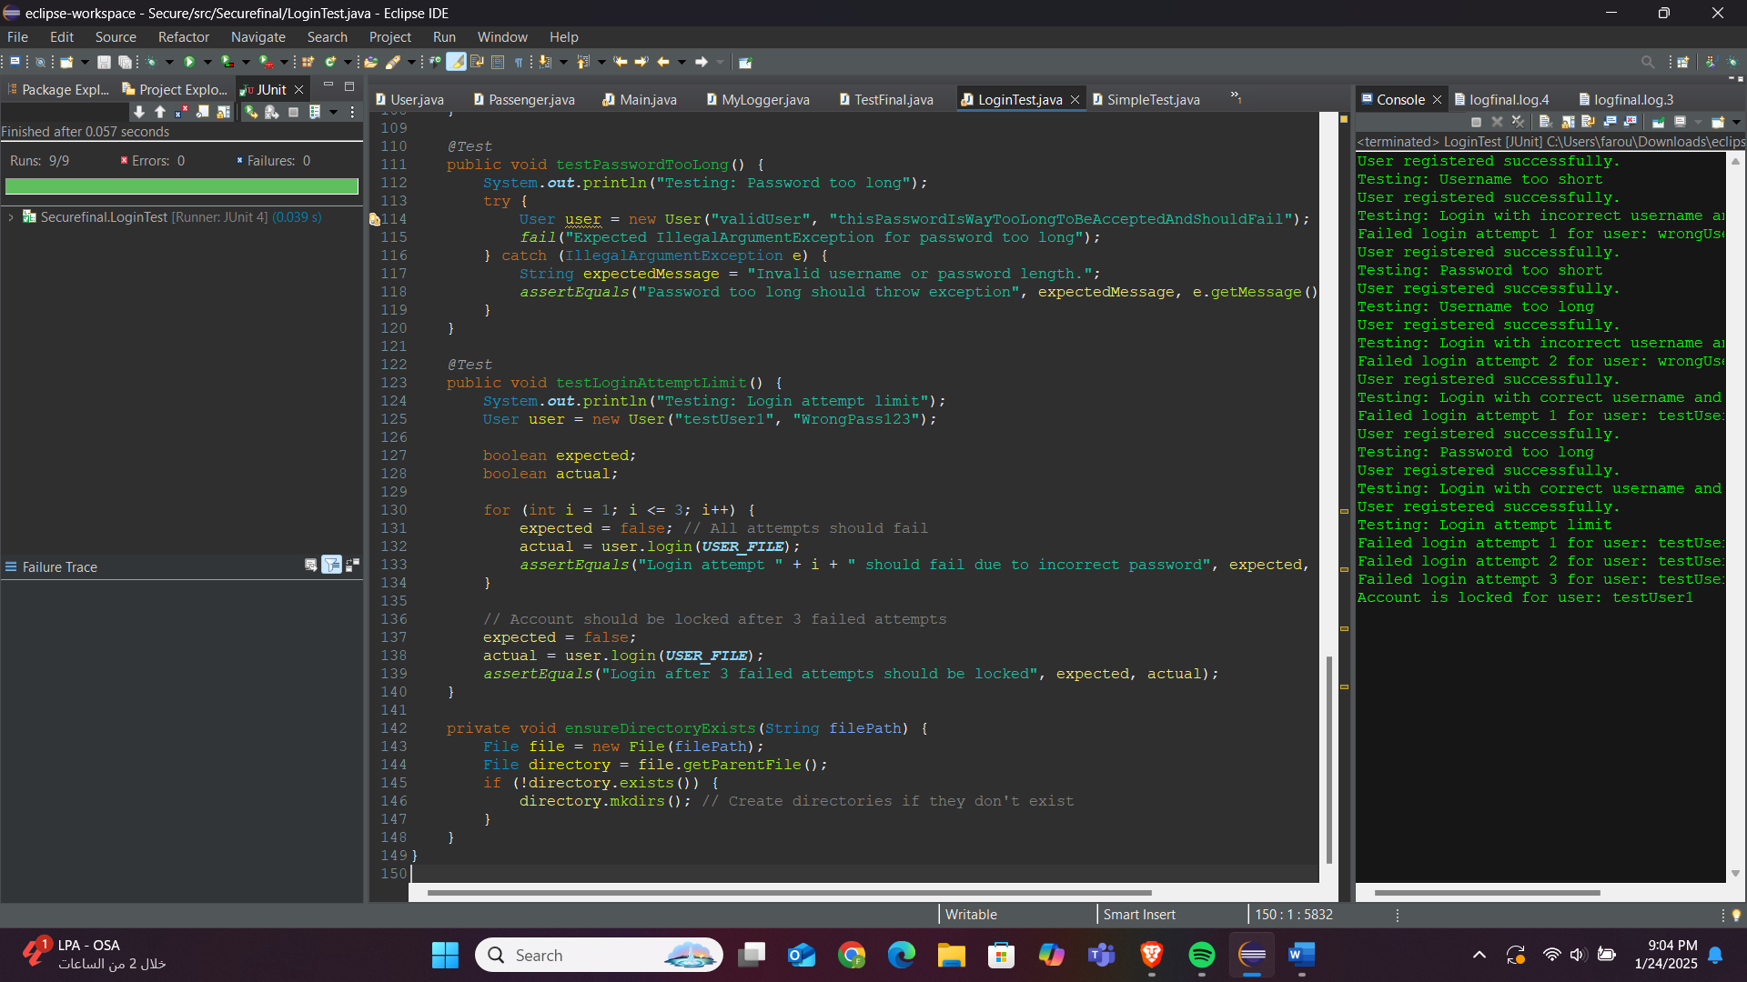

**Password Policy Test Cases**

|  |  |  |  |  |  |
| --- | --- | --- | --- | --- | --- |
| Test ID | Test case description | Inputs | Expected | Actual | Status |
| UT001 | Verify valid password | password: Valid@123 | Password meeting all criteria should be valid | Password meeting all criteria should be valid | Pass |
| UT002 | Verify password too short | password: Short1! | Password less than 8 characters should be invalid | Password less than 8 characters should be invalid | Pass |
| UT003 | Verify password too long | password: ThisPasswordIsWayTooLong123! | Password more than 20 characters should be invalid | Password more than 20 characters should be invalid | Pass |
| UT004 | Verify password missing uppercase | password: valid@123 | Password without an uppercase letter should be invalid | Password without an uppercase letter should be invalid | Pass |
| UT005 | Verify password missing lowercase | password: VALID@123 | Password without a lowercase letter should be invalid | Password without a lowercase letter should be invalid | Pass |
| UT006 | Verify password missing digit | password: Valid@Pass | Password without a digit should be invalid | Password without a digit should be invalid | Pass |
| UT007 | Verify password missing special character | password: Valid1234 | Password without a special character should be invalid | Password without a special character should be invalid | Pass |
| UT008 | Verify empty password | password: '' | Empty password should be invalid | Empty password should be invalid | Pass |
| UT009 | Verify password with spaces only | password: ' ' | Password with only spaces should be invalid | Password with only spaces should be invalid | Pass |
| UT010 | Verify password hashing consistency | password: Consistent@123 | Hashing the same password should produce the same result | Hashing the same password should produce the same result | Pass |
| UT011 | Verify password hashing irreversibility | password: Irreversible@123 | Hashed password should not match the original password | Hashed password should not match the original password | Pass |
| UT012 | Verify password hashing uniqueness | password1: Unique@123, password2: Different@123 | Hashing different passwords should produce different results | Hashing different passwords should produce different results | Pass |

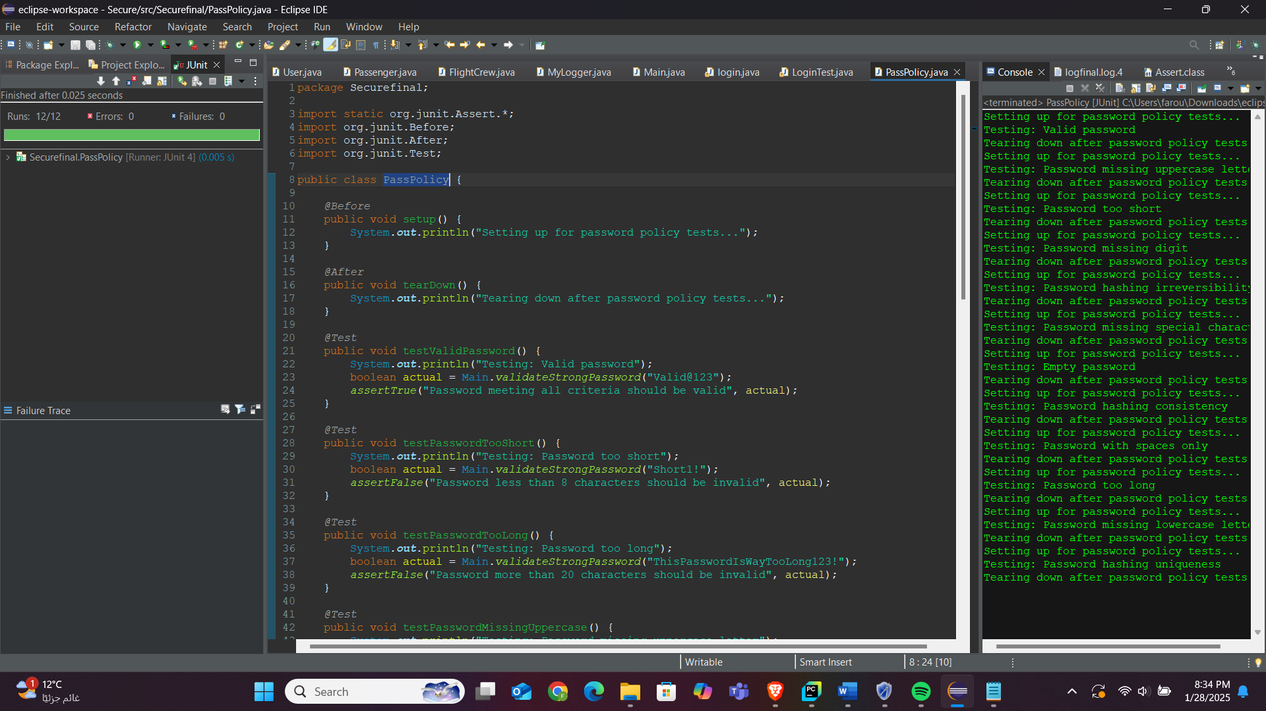

**Integration testing**

Register passenger

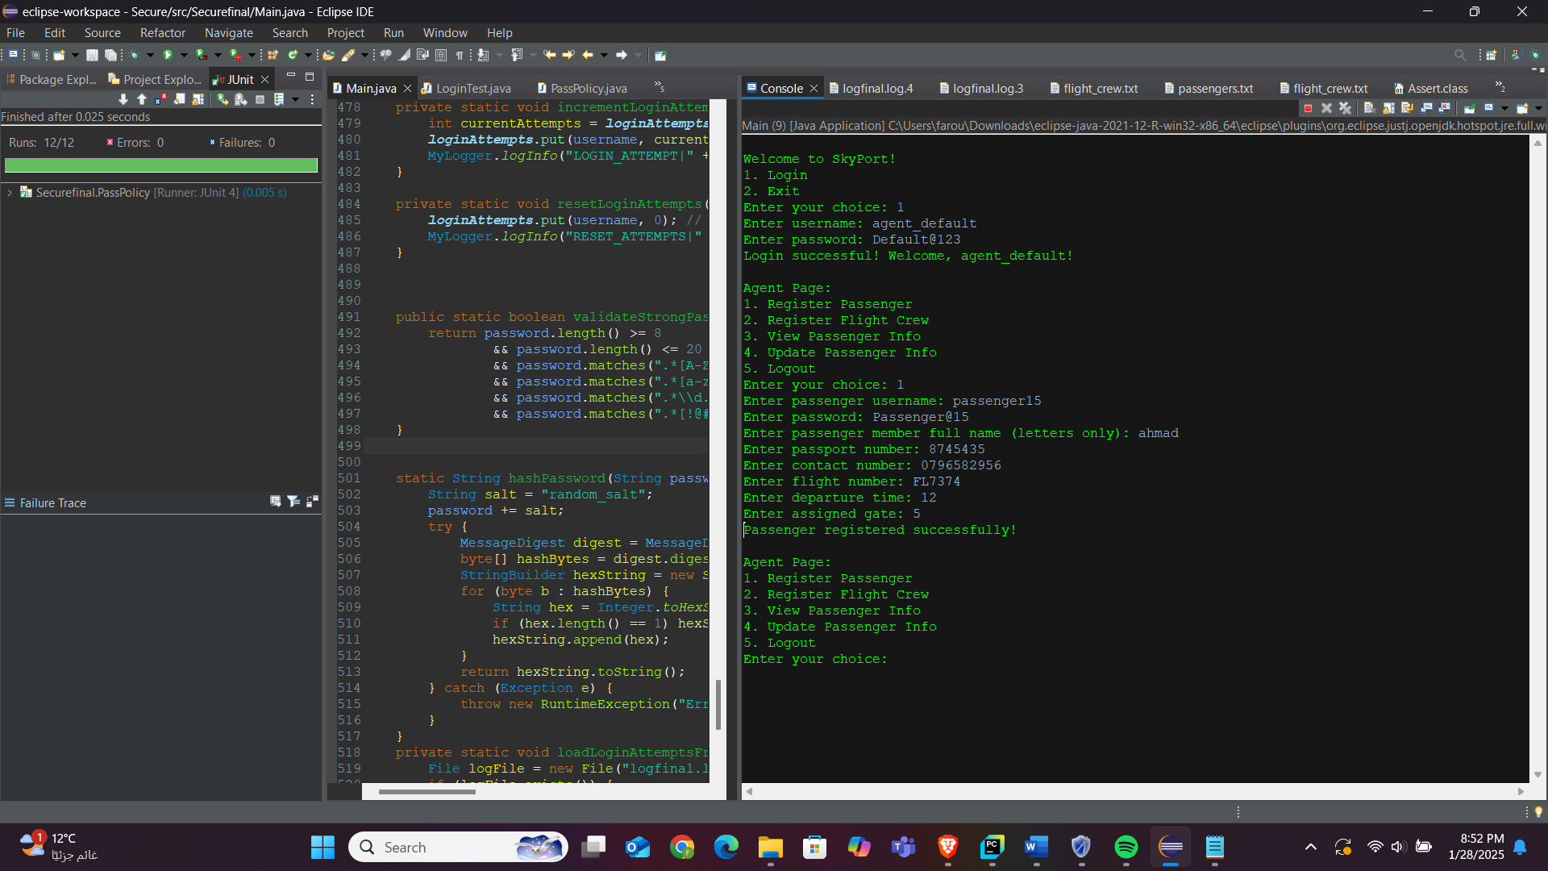

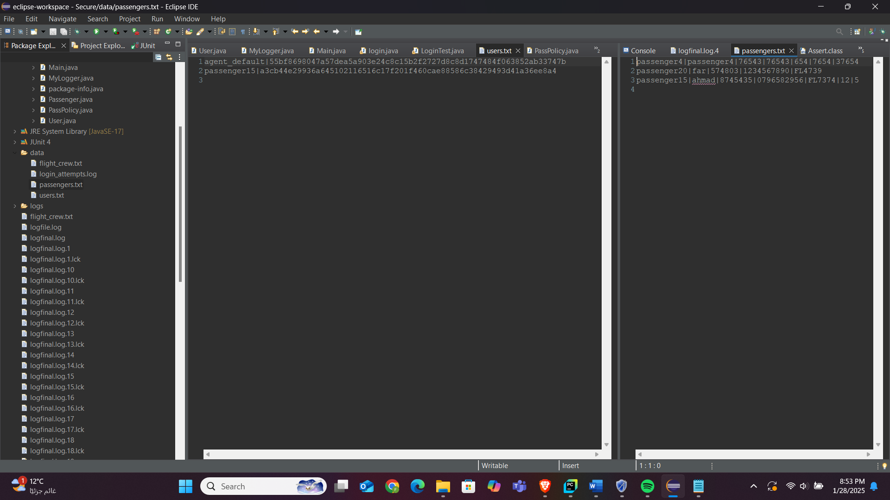

Register flight crew

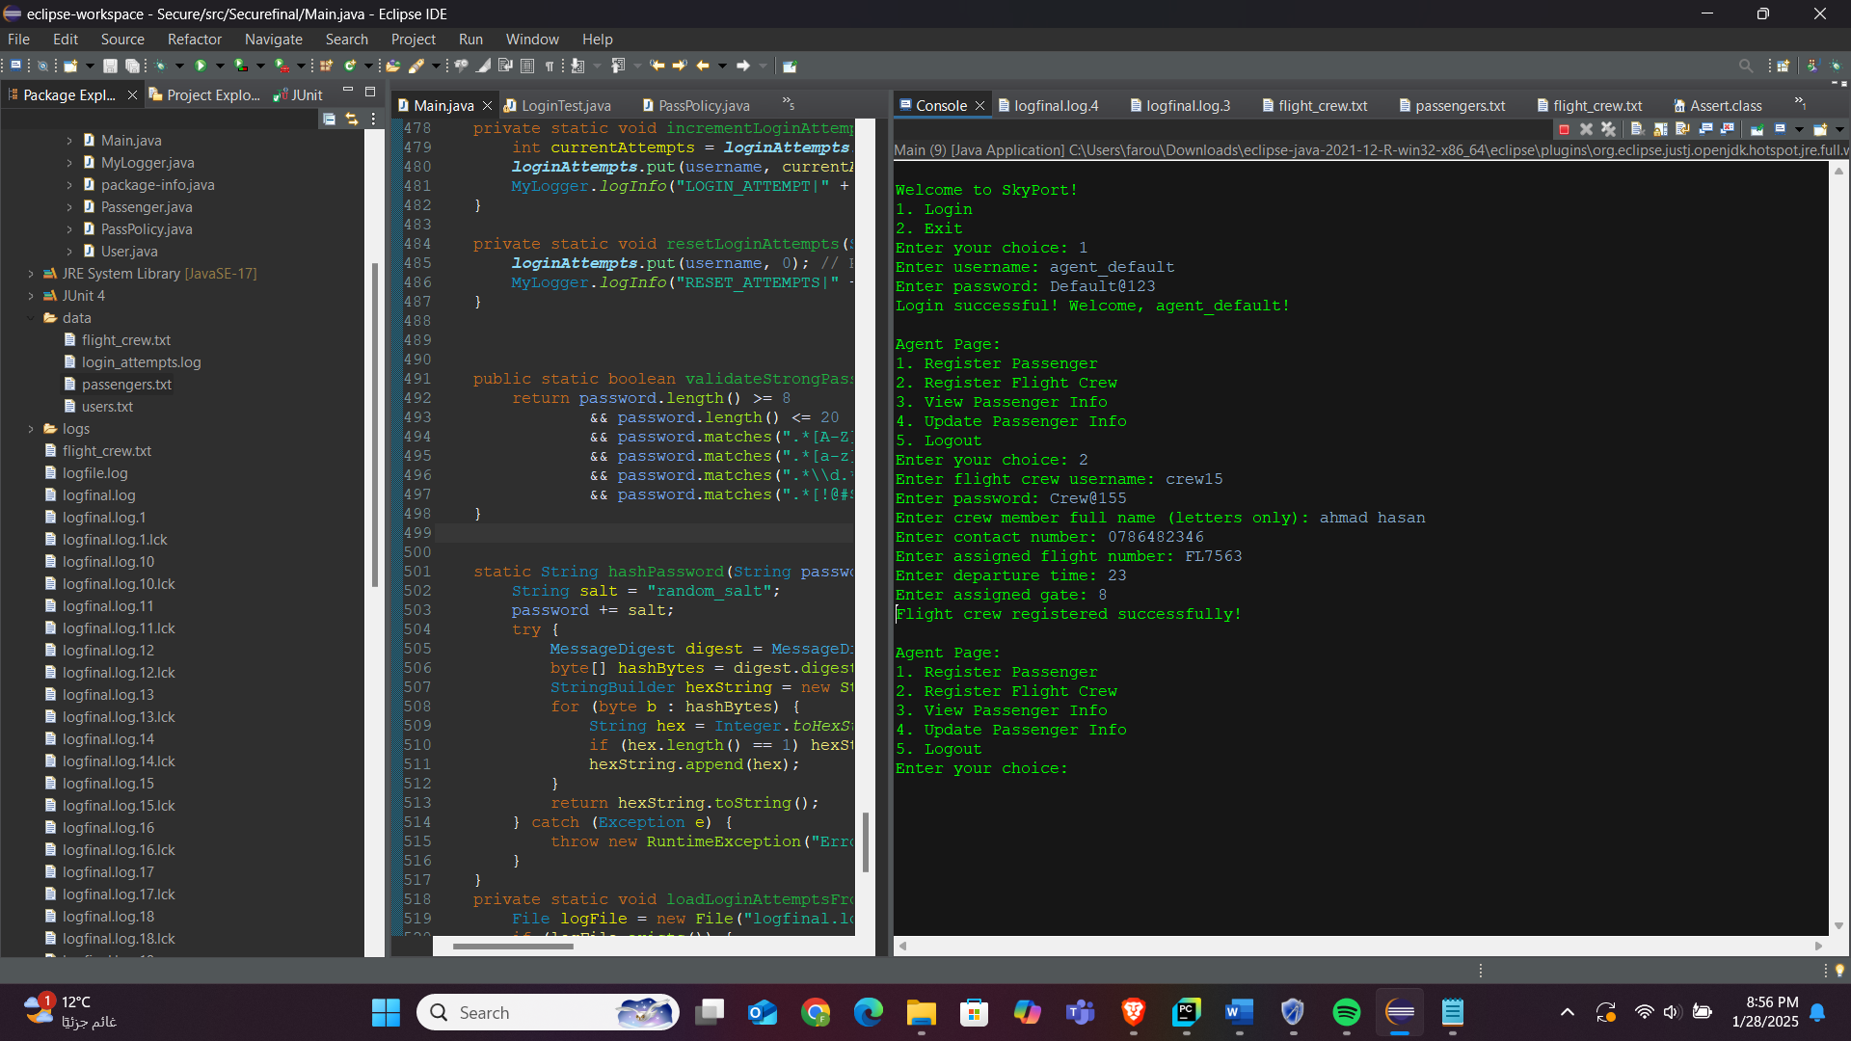

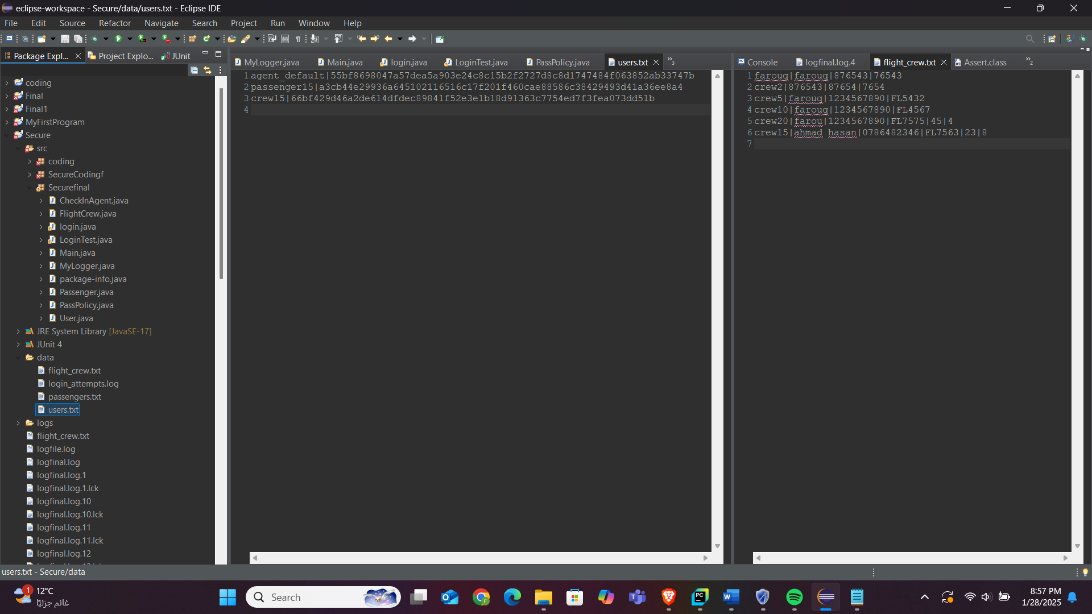

Logger working fine   
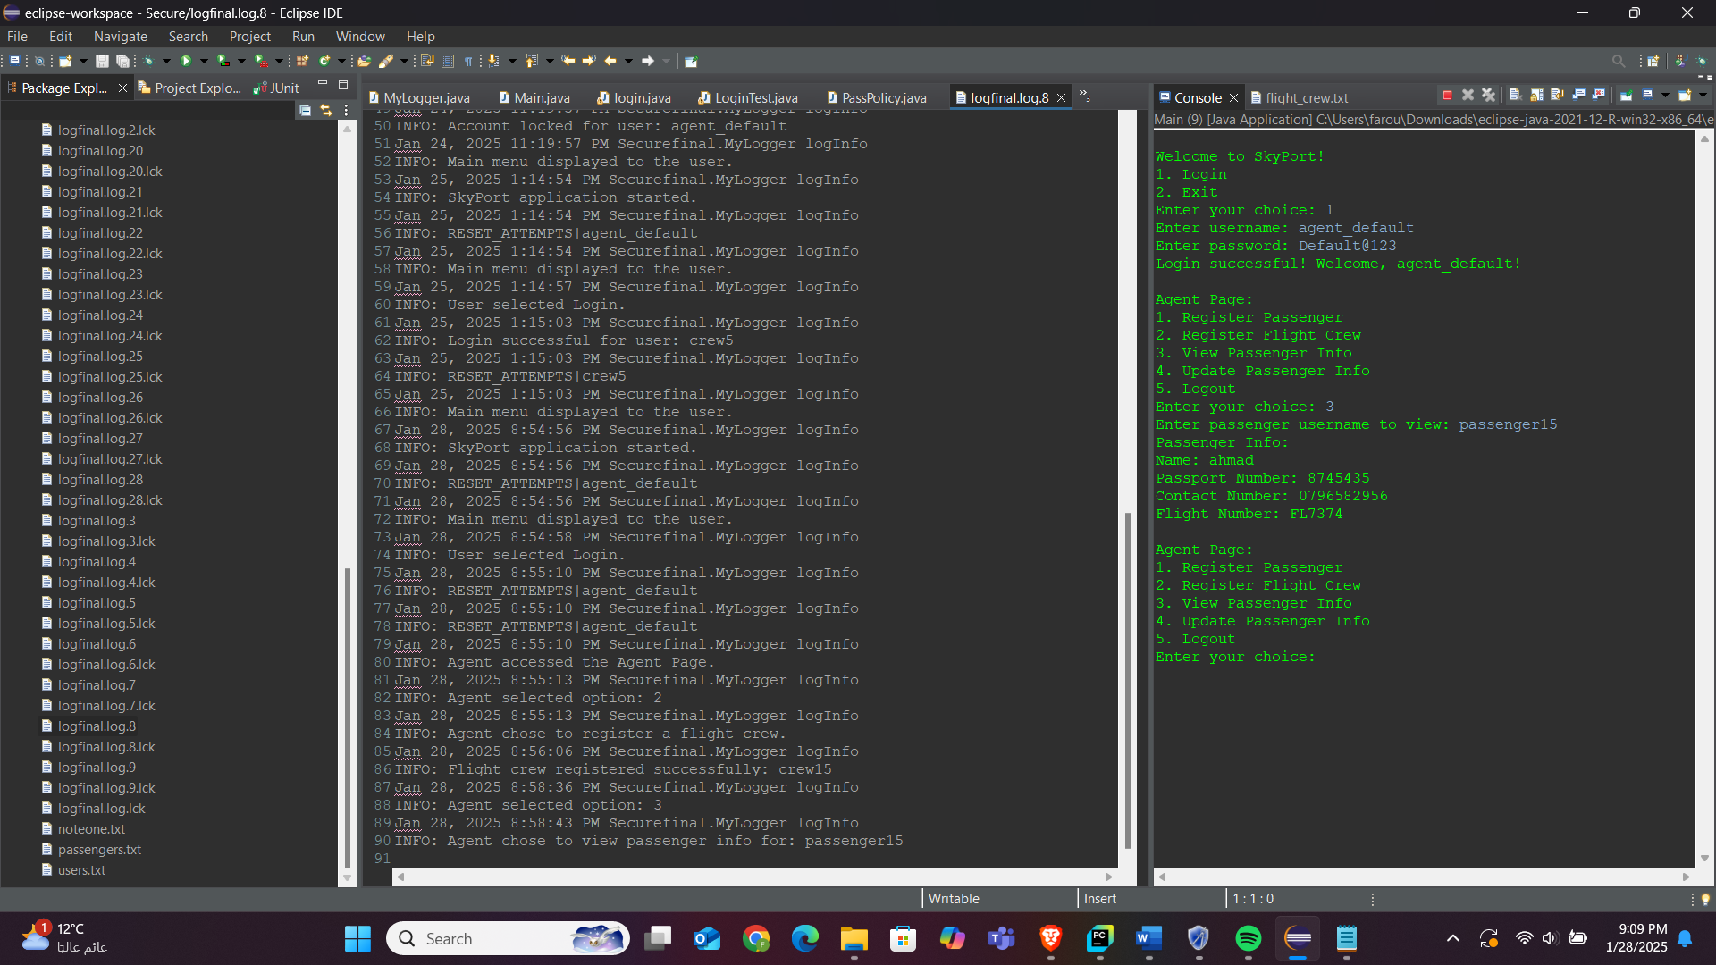

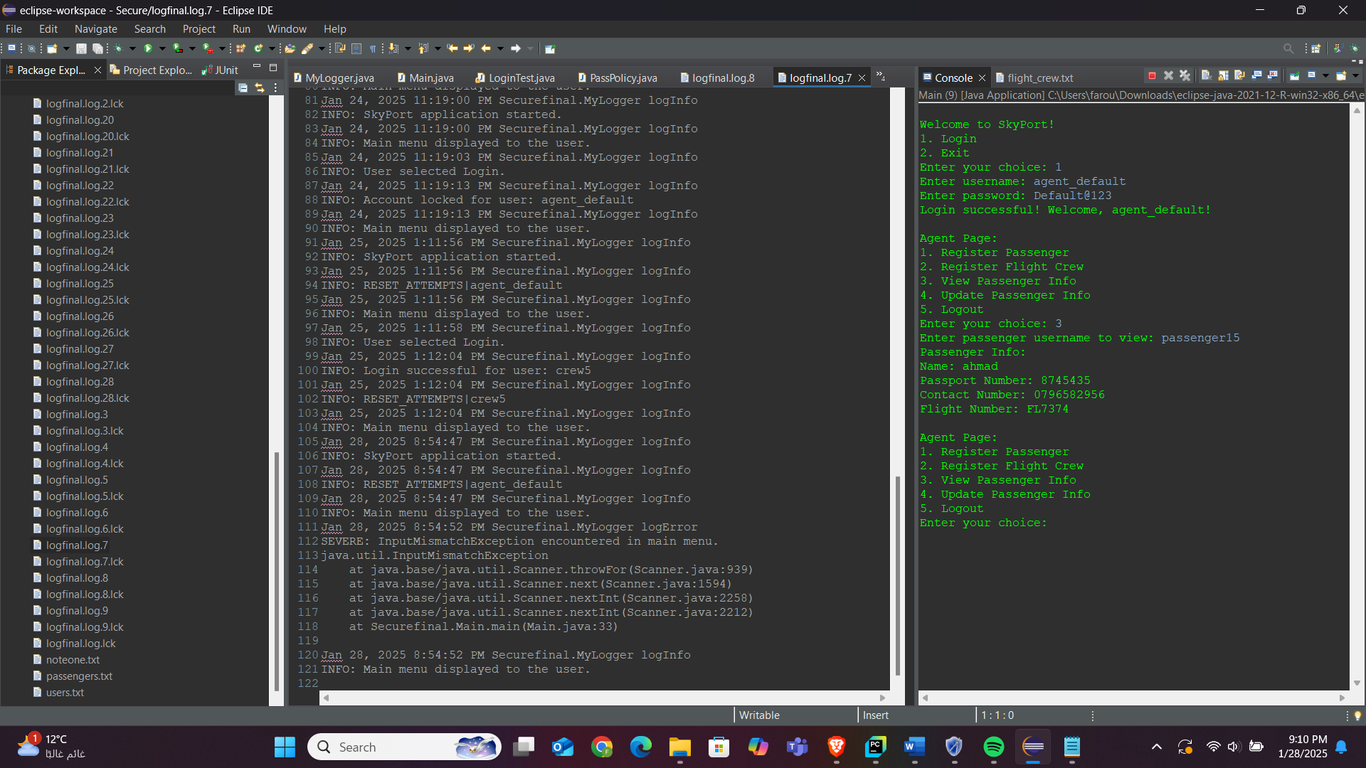

**Smoke testing**

Passenger can login and view and update his information successfully

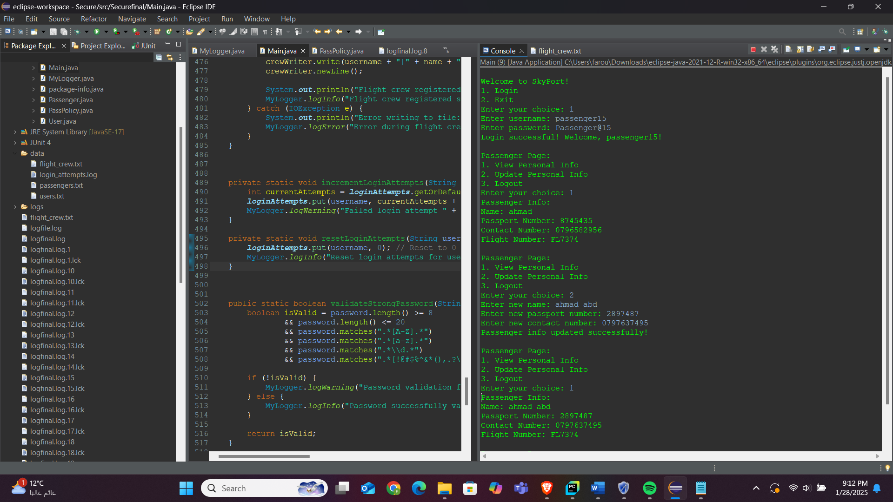

Flight crew can login and view this information

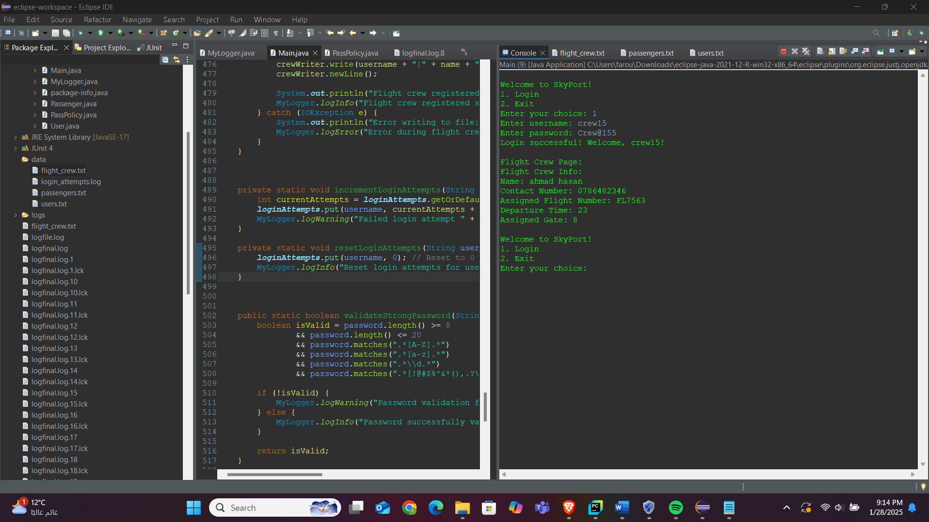

1. Apply security-based testing techniques such as fuzz testing and provide screenshots for the testing.

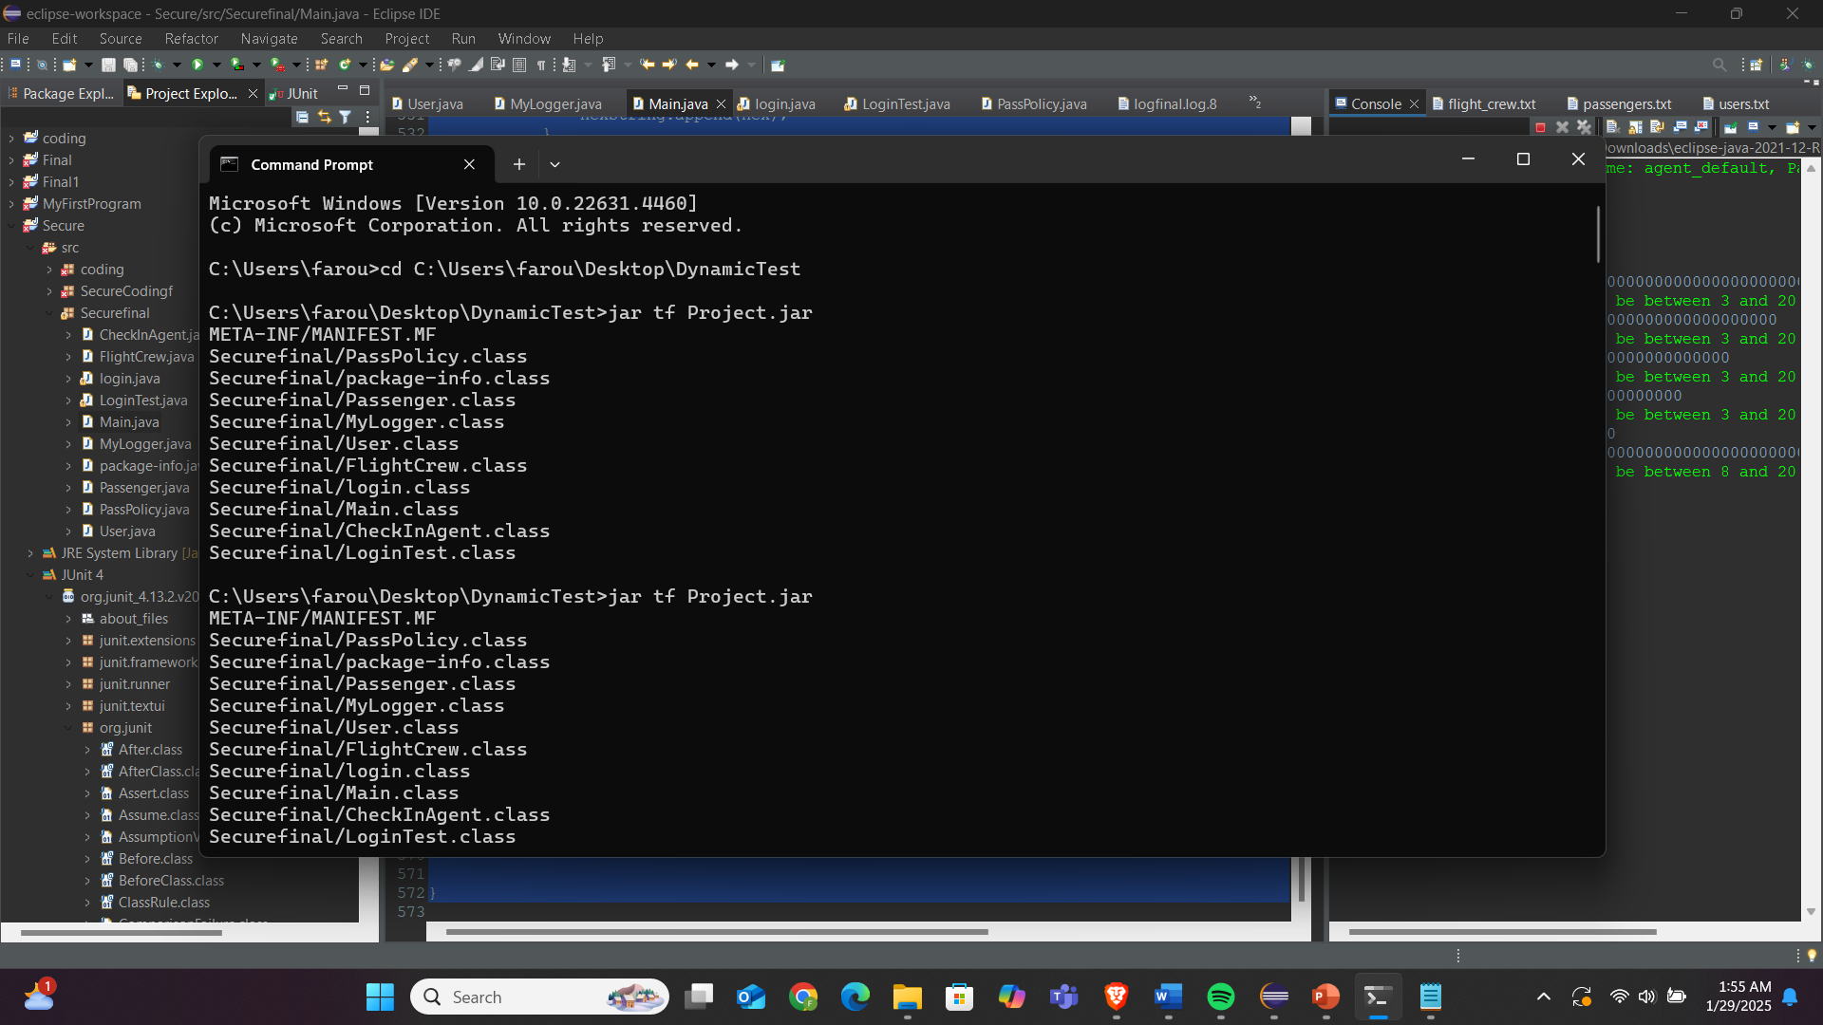

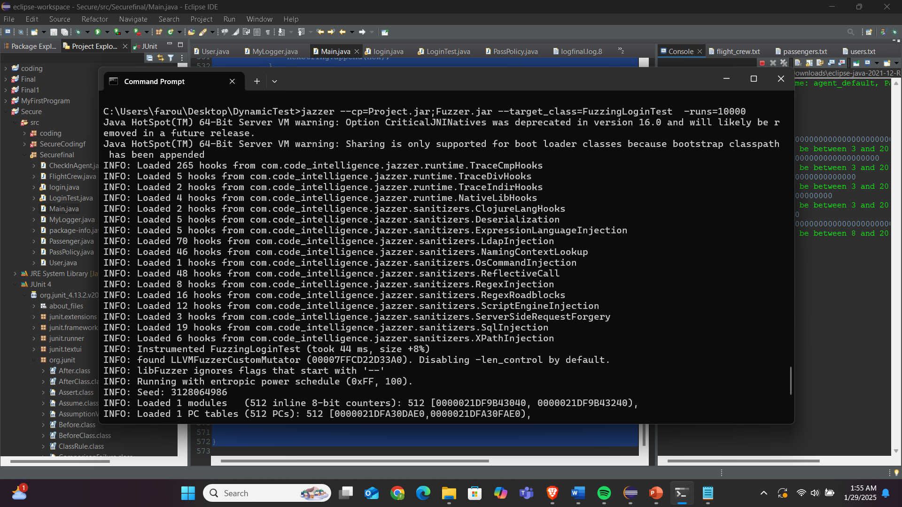

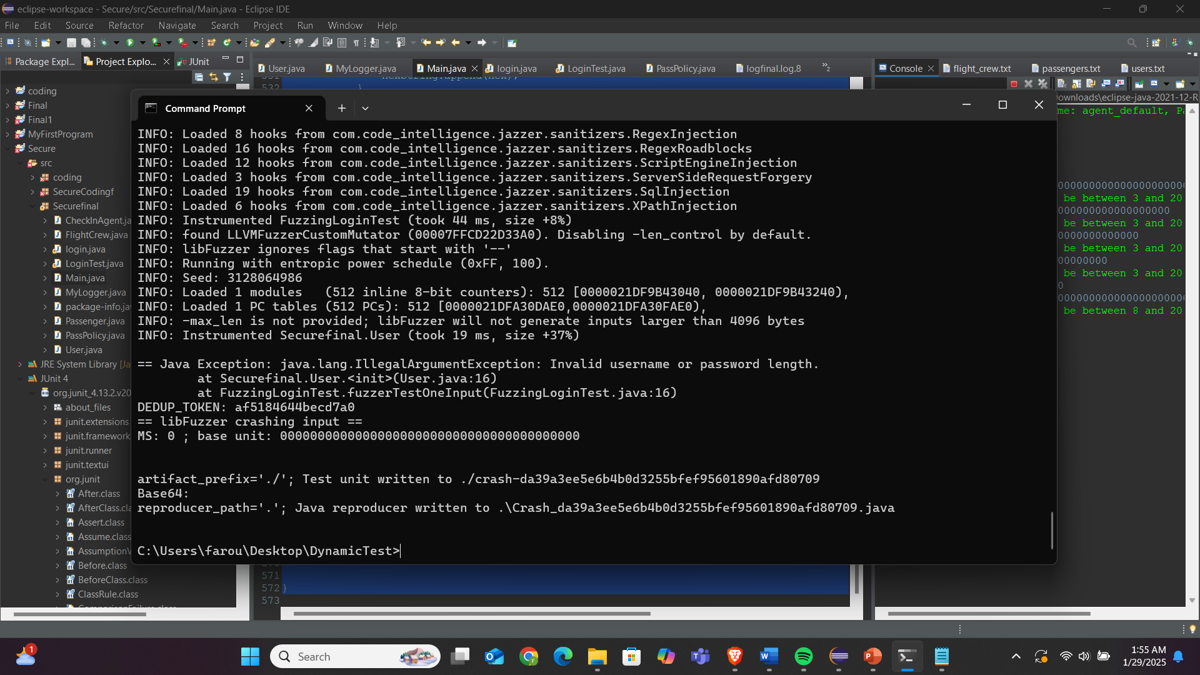

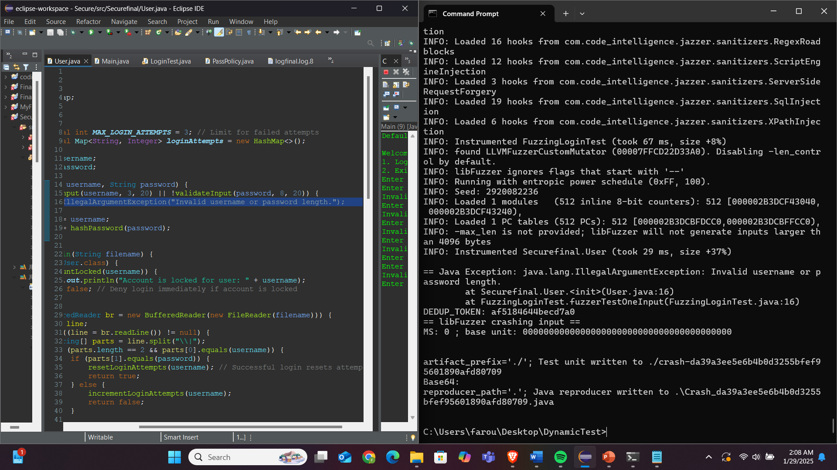

I removed the throw so I can test the whole options

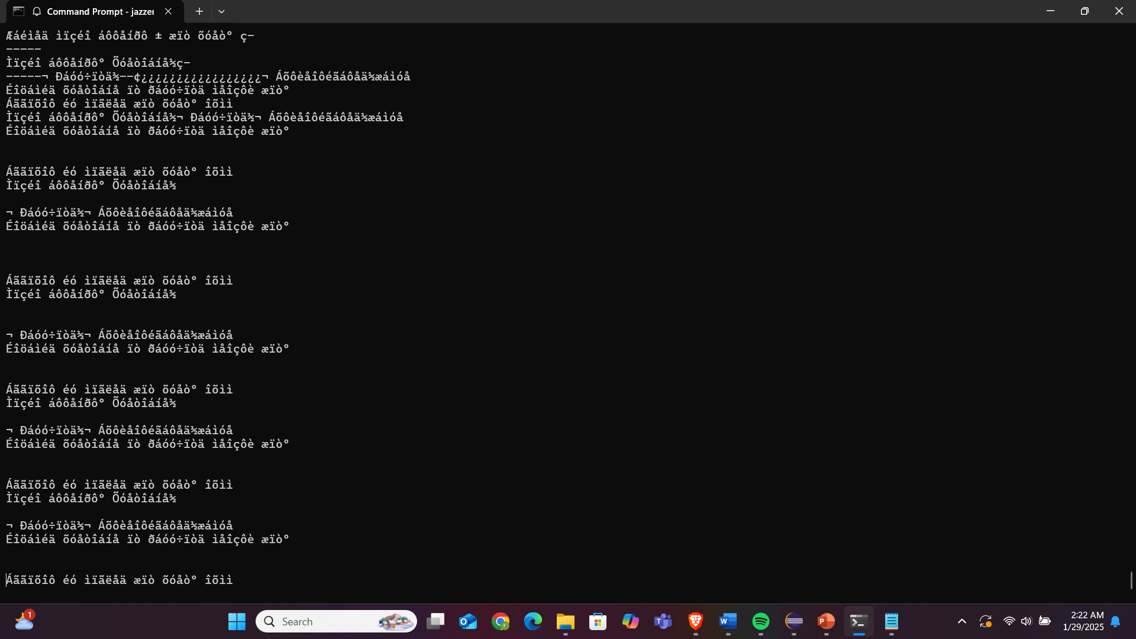

This is for the login function

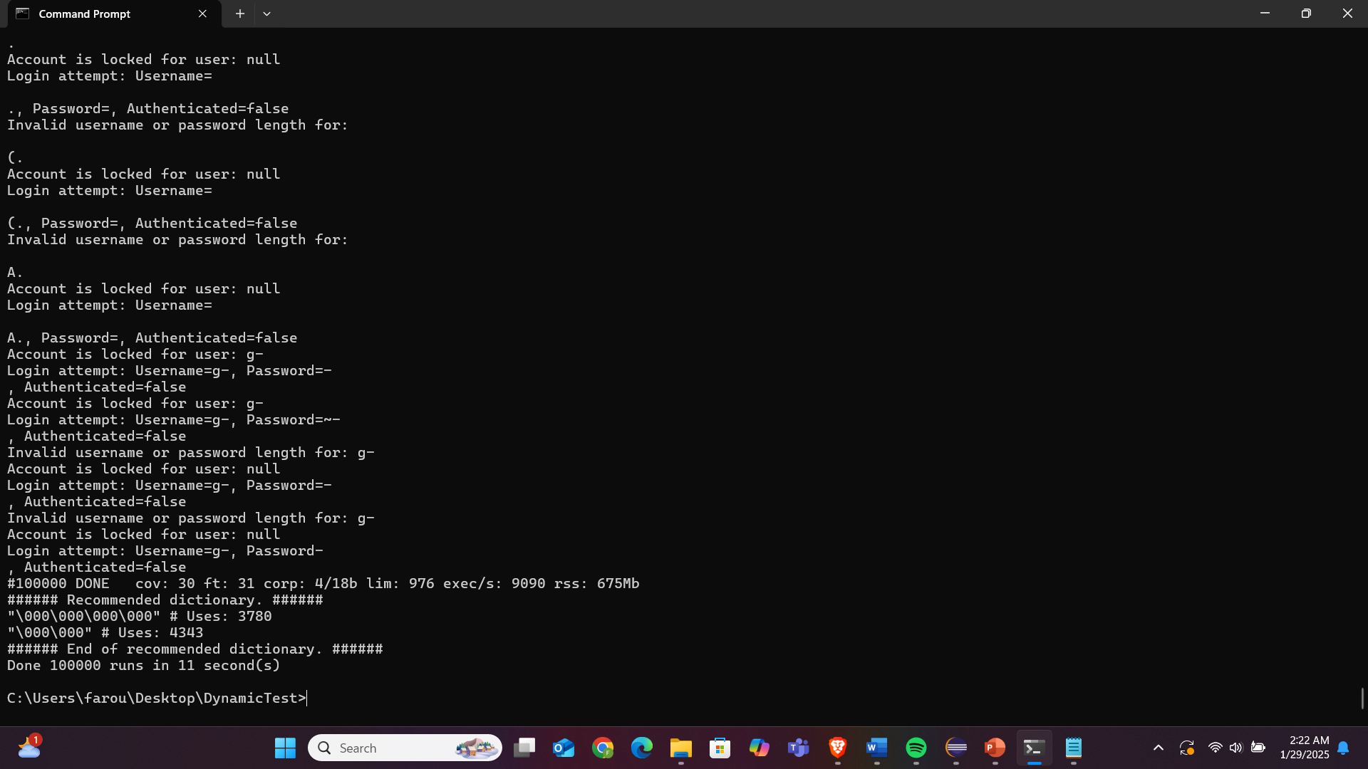

And for the login 1k   
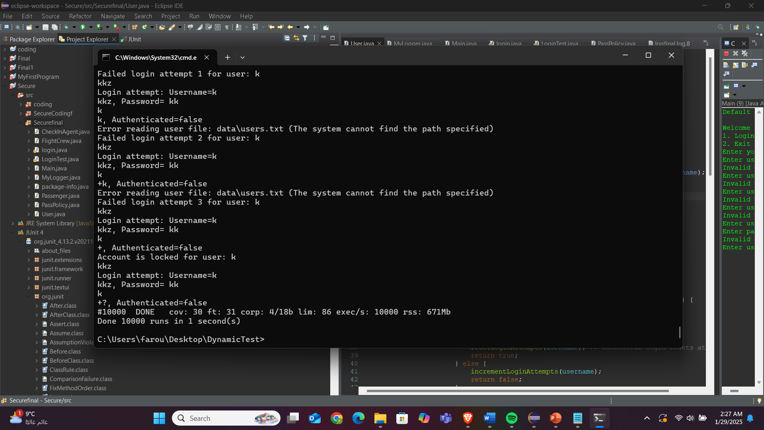

Then 10k

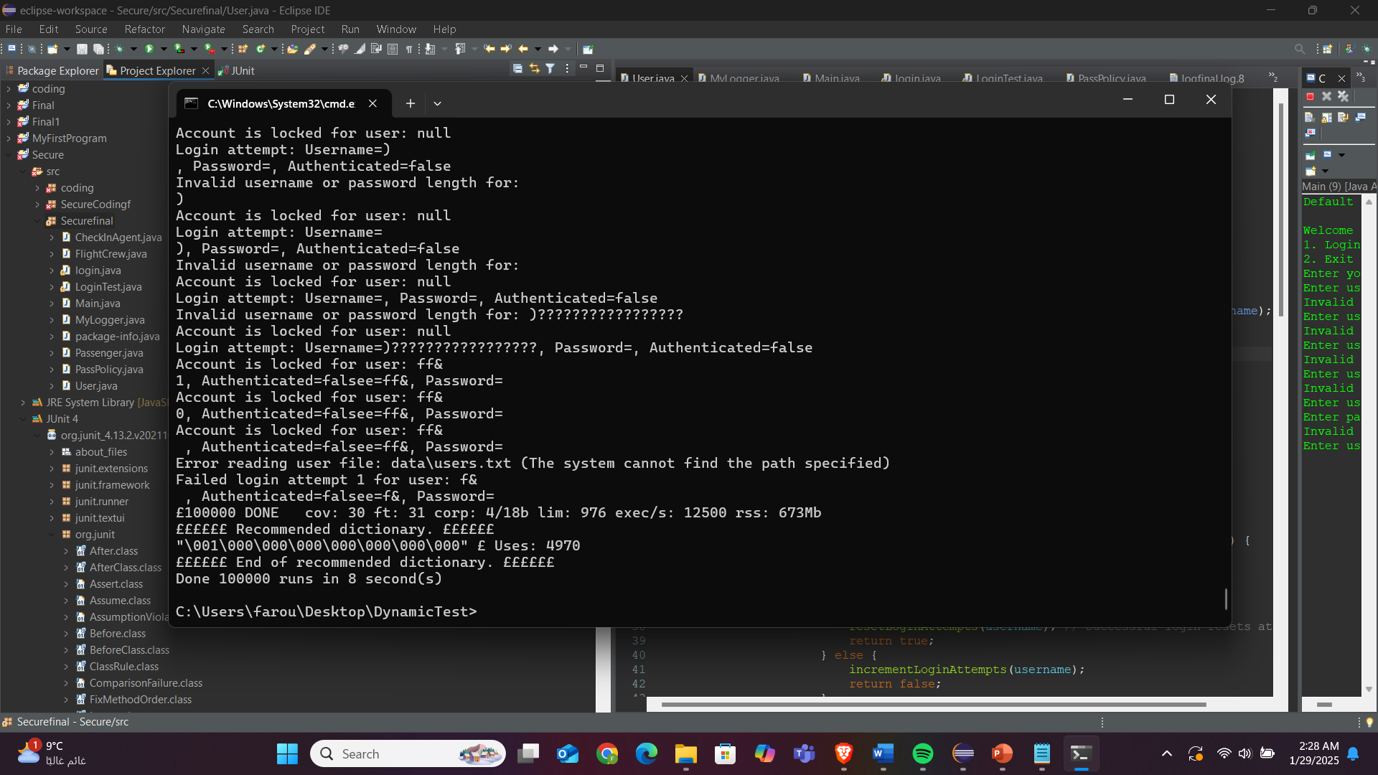

Then 100k

Next time I need to give less attempts

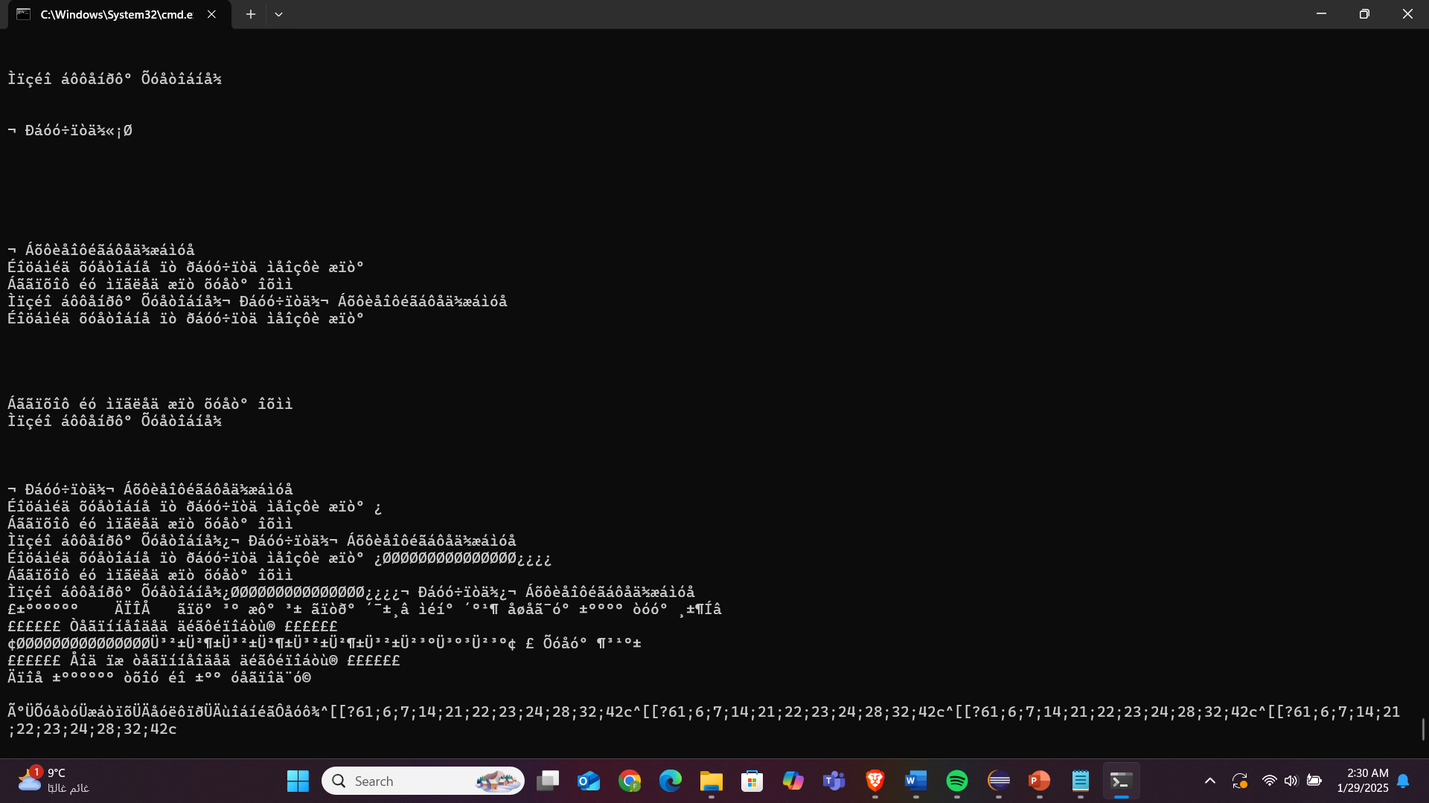

This is for password policy

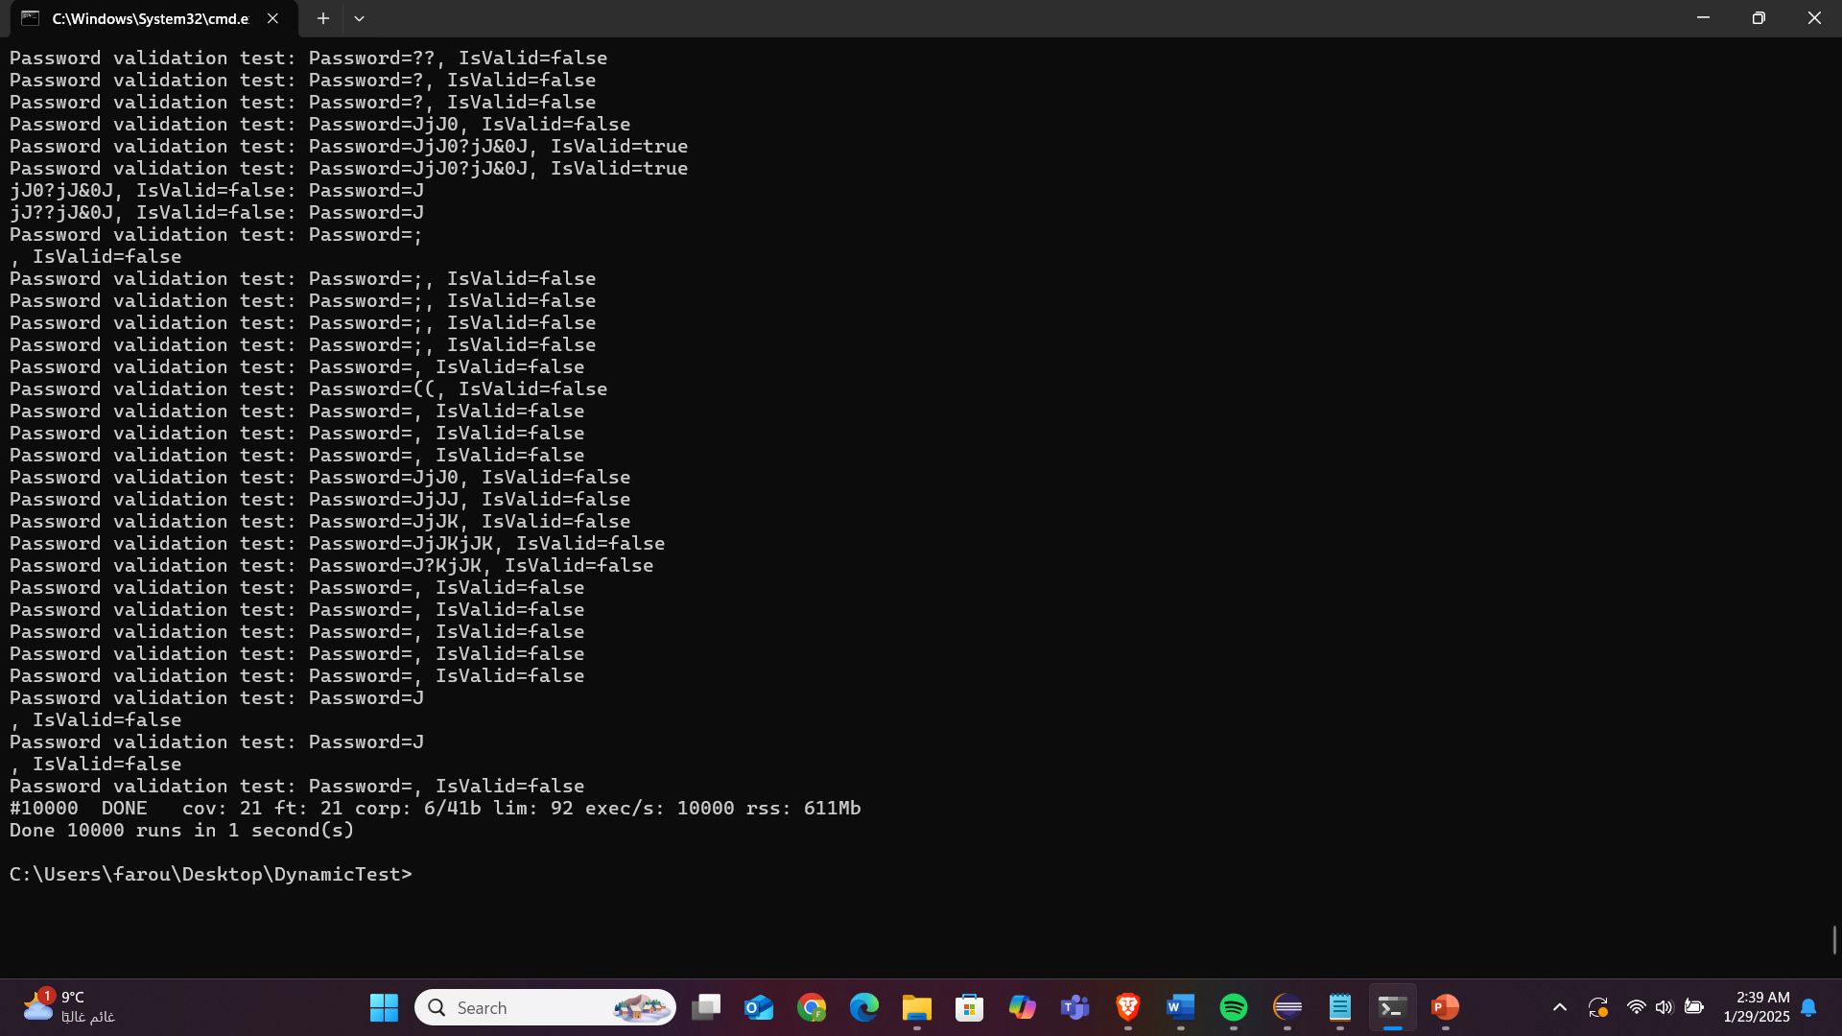

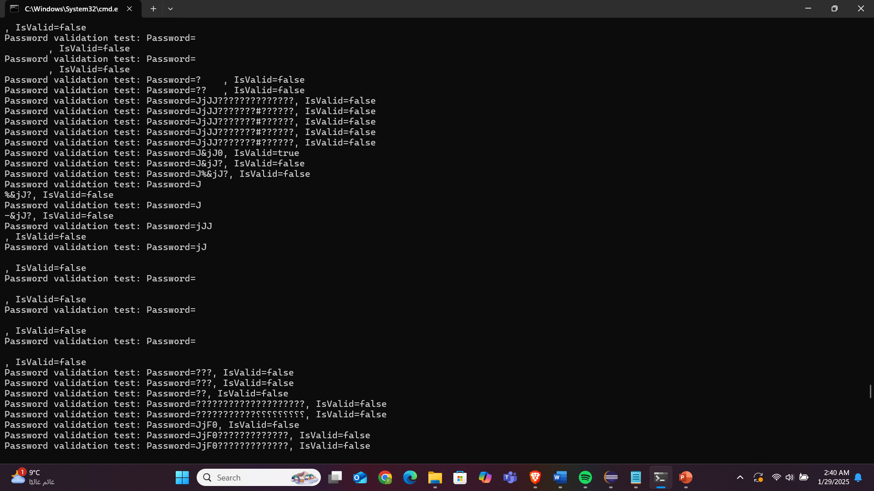

1. Apply code review analysis and provide screenshots

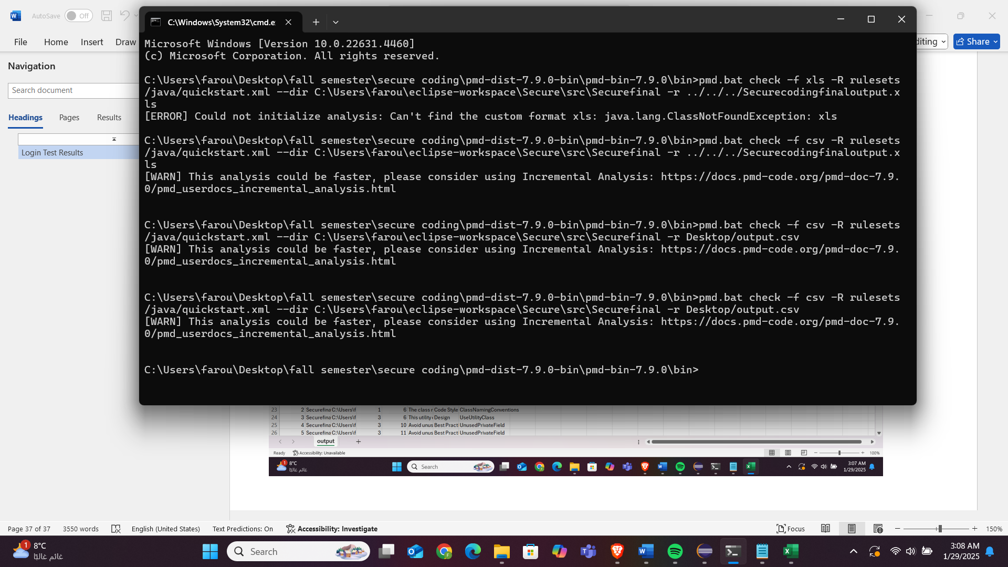

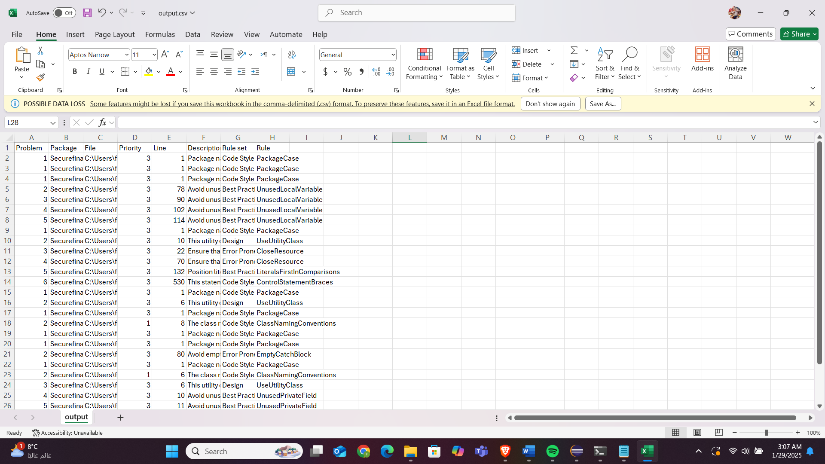

https://github.com/farouq7assan0o/SecureCoding.git